Chapter ?, Criterion Four
Teaching and Learning:
Evaluation and Improvement
The institution demonstrates responsibility for the quality of its educational programs, learning environments, and support services, and it evaluates their effectiveness for student learning through processes designed to promote continuous improvement
SMSU faculty are deeply committed to teaching and student learning and have been engaged in assessment activities for many years. Faculty as well as other staff in areas across the university continue to learn about the value of and rationales for participating in ongoing assessment; University members are vested in continuously improving student learning. Prior to the 2004 HLC review, several years of focused university attention resulted in departments and programs developing outcomes-based assessment goals and plans and seeking support to do so through mini-grants offered by the Committee on Institutional Assessment (CIA). (See the 2004 Self-Study [link] for a history of these efforts.) Following 2004, the overall assessment focus shifted to instituting a stable cycle of program review and the revision, implementation, and assessment of the new Liberal Education Program (LEP) outcomes. While some individual faculty and programs continued with their assessment efforts, during the revision of the LEP, they were not the focus of an institutional imperative; however, attention to the “whole” of assessment efforts was reinvigorated in 2012 with the appointment of an assessment coordinator reassigned part-time from faculty, the revitalization of the CIA, and a focus on sustainable assessment. The assessment coordinator provides support for department and program assessment efforts, and the Liberal Education Committee (LEC), the oversight body for the new LEP, is responsible for conducting assessment of the LEP outcomes. The CIA, co-chaired by the assessment coordinator and the Dean of ALS, is charged with communicating with the Strategic Planning committee to ensure that assessment efforts and evidence are considered in that committee’s work. The commitment to sustainable assessment is included in SMSU’s 2012-2017 Strategic Plan: Academic Strategic Direction, Goal 4 specifically states that the institution will “review annually all academic programs to insure continuous improvement” and “annually assess whether academic programs and the Liberal Education Core are meeting stated outcomes.”
This chapter will describe how SMSU’s multi-pronged approach to assessment, through the efforts of the assessment coordinator, the LEC, the CIA, and departmental reporting and program review, ensures that the University provides quality education to its students. All of the undertakings over the past ten years related to assessment, credit policies, curriculum programming, student services, and retention demonstrate the University’s ongoing commitment to continuous improvement.

Core Component 4A. The institution demonstrates responsibility for the quality of its educational programs.
SMSU employs a variety of processes for assuring the quality of its educational programs and student learning experiences. Five-year academic program self-studies (i.e., reviews) and department annual reports are venues for consistent assessment of program quality, and the University has spent considerable time reviewing and strengthening its policies and procedures for transcripting credit over the past several years. The curricular process for the approval of all courses, degrees, and certificates is well-defined and requires approval at multiple faculty and administrative levels. Furthermore, the curricular process ensures that faculty have authority over course prerequisites, course rigor, and student learning outcomes. SMSU’s dual credit program, College Now (CN), meets all requirements and expectations for accreditation by the National Association of Concurrent Enrollment Partnerships (NACEP). In addition, all CN courses are subject to SMSU program, departmental, and university policies. Several programs in addition to CN retain specialized accreditation or meet other licensure or approval criteria. The University is able to boast a 99% employment rate of its graduates, a strong sign of success in addition to other measures. Each of these elements is described in greater detail in the following subcomponent sections.

4A1. The institution maintains a practice of regular program reviews.
At SMSU, program review takes two forms: periodic five-year self-studies with an external reviewer who reads the review and comes to campus, and annual reporting by departments.

Academic Program 5-Year Self-Studies
The Provost/Vice President for Academic & Student Affairs is responsible for oversight of all academic and non-academic programs at SMSU. Academic program self-studies (also called program reviews) have been instituted at SMSU since 1974 (see list of program reviews in Striegel Archives in the SMSU library).
In 2006-2007, the administration announced a new emphasis on and timeline for ongoing program reviews. SMSU’s policy for program self-studies as well as guidelines for self-study completion are now located on the Academic Deans’ webpage (http://www.smsu.edu/administration/academicdeans/?id=3772) and consist of four basic documents: 1) “Program Planning and Review Procedures” (essentially a link to the “Academic Program Planning and Review Procedures” document), 2) “Guide to Program Self-Study Report,” 3) “Guide to External Consultant’s Report,” and 4) “Navigating Your Way through a Program Review.” The first item listed, the “Academic Program Planning and Review Procedures” document, has a posting date of 2002 and was revised in 2007, when the two guides were published. More recently, the “Navigating” document was posted in 2012 to clarify expectations from the Deans regarding the process.
The most recent self-study documents align with an effort by the Provost to revitalize the program self-study process by implementing a five-year program self-study schedule (t-drive, HLC criterion 4A1). Though a few programs have steadily resisted complying with the program review timeline, the percentage of program reviews completed has been rising. For example, by 2004-2005, of the 22 academic programs in the College of Arts, Letters, and Sciences (ALS), 27% had completed a previous self-study. Five years later, (i.e., 2009-2010), 73% of ALS programs had completed a program review, and by 2013-14, 91% of ALS programs had completed at least one program review. Several ALS programs are scheduled to complete their program self-study during 2014-2015, which will bring the percentage of ALS programs completing at least one self-study to 100%.
The completion rate for program self-studies in the College of Business, Education, and Professional Studies (BEPS) has also increased over time, although not as dramatically as in ALS. Thirty-eight percent of programs completed a self-study by 2004-2005, 46% had completed a self-study by 2009-2010, and by 2013-14, 54% of programs completed at least one program self-study. A number of BEPS programs are also scheduled to complete their program self-study in 2014-2015. It should be noted that the composition of BEPS has not remained static over the last ten years. Four new agriculture-related programs were added to BEPS effective Fall 2013. Nursing was also a new program added in Fall 2013. This makes the completion rate appear low, because the new programs have not been in existence long enough yet to warrant program review.
The increase in number of programs engaging in a self-study in recent years resulted from the Administration’s decision to link allocation of resources to program quality and efficiency as self-reported and corroborated by an external reviewer. Previously, many programs viewed mandated self- studies as busy work; in other words, the administration did not clearly articulate the inherent value of the self-study process to the program, department, and the university. Furthermore, there was little incentive (or reward) for programs completing a self-study, and there were no dis-incentives for programs that consistently refused to comply. Additional evidence that the University itself undervalued program self-studies lies in the fact that there had been no oversight or designated repository for self-studies that is accessible by University members.
While the procedure has always contained a final step in which the program under review can respond to the external reviewer’s suggestions and must write out a five-year plan in accordance with those suggestions, more recently the administration has emphasized this reflective step. As part of their reflective response, programs were expected to provide a timeline for the implementation of practices/policies suggested by the external reviewer that targeted program concerns/weaknesses for the ultimate goal of providing and maintaining high-quality instruction that align with and support the department’s mission as well as the University’s mission and vision.
Past practice dictated that program reviews were shared primarily between the affected program and the respective Dean. Once the review was completed, it was shelved. Consequently, locating these early program reviews has been challenging, as there appears to have been no dedicated, central storage site for these reports throughout SMSU’s history. Program self-studies now are in several locations including program file space on the University’s t-drive, the Striegel Archives in the SMSU Library, the Academic Deans’ office, and/or the individual program/department offices.
In an attempt to increase transparency of program self-studies, since 2012, the CIA has been engaged in discussion of how the self-study process may be amended such that completed self-studies must be reviewed by the CIA in addition to the Dean. Linking the program’s self –study to the CIA webpage is an ongoing point of discussion. As program self-studies are located and compiled, a dedicated space will need to be determined to house all reports for future reference.

Academic Department Annual Reports
The Administrative Dean’s office implemented Department Annual Reports in 2004-2005. The format of the Annual Reports aligned with the faculty professional development and evaluation criteria as defined by the Inter-Faculty Organization (IFO) and Minnesota State Colleges and Universities (MnSCU) Master Agreement. The five criteria are: 1) demonstrated ability to teach effectively and/or perform effectively in other current assignments, 2) scholarly or creative achievement or research, 3) evidence of continuing preparation and study, 4) contribution to student growth and development, and 5) service to the university and community. Early Department Annual Reports (i.e., FY2005-06) also included a summary of courses taught by faculty within the department, faculty professional accomplishments, and program/department highlights. In FY07, departments were directed by academic Deans to include program and department mission and vision statements, student learning outcomes, and program budgets in the reports. The FY12 Department Annual Reports include number of majors in each program and a summary of College Now activities by the programs within the department.
The administration continues to refine and more explicitly define the contents of the Department Annual Report. For example, although assessment is part of the Department Annual Report format, it lacks specific guidelines as to the kind and extent of assessment data that should be provided by programs and departments. In 2013, administration revised the Department Annual Report format to include specific data requirements and a more extensive assessment component. Making Department Annual Reports public information by posting them on the academic Dean’s website increases transparency of department activities for the University, regional, and national communities.
The most recent Department Annual Reports can be found on the academic Deans’ webpage (http://www.smsu.edu/administration/academicdeans/?id=3780), with earlier Annual reports found in e-resources or in the HLC resource room.
4A2. The institution evaluates all the credit that it transcripts, including what it awards for experiential learning or other forms of prior learning.
SMSU adheres to MnSCU policies and procedures for transcription of credits; see the “Educational Policies” chapter from the collection of Board policies and System procedures on the MnSCU website (http://www.mnscu.edu/board/policy/index.html) for a complete list of the MnSCU policies related to this subcomponent. In addition to common procedures for transcripts, MnSCU policies include guidelines on Advanced Placement, International Baccalaureate, CLEP, credit for prior learning, and transfer.
SMSU has in turn developed its own policies; most recently, a Credit for Prior Learning policy and procedure for SMSU was approved in April 2013 (http://www.smsu.edu/nca/policies/a-050%20credit%20for%20prior%20learning.pdf and http://www.smsu.edu/nca/policies/a-050.1%20credit%20for%20prior%20learning%20procedure.pdf.) An internship policy (http://www.smsu.edu/nca/policies/A-008%20Internships%20Policy.pdf ) guides overall university practice regarding internship credit, with departments creating their own procedures in line with the policy. Twenty-seven SMSU programs offer internship credits, and the majority of these have their own program-specific internship policies. The program-specific policies are generally more prescriptive than the SMSU policy. However, the SMSU internship policy does not always align or complement program policy. Future meet and confer agenda discussions should address this.
SMSU’s grading policy (http://www.smsu.edu/nca/policies/a-034%20grading%20policy.pdf) also provides the necessary parameters for grading options and how evaluation of a students’ performance will be transcripted. The grading policy and GPA calculation information is also provided in the Student Handbook, in order to make the University policy clear for students (http://www.smsu.edu/administration/studenthandbook/?id=8093). In 2012-2013, SMSU developed and adopted Policy A-049 Credit Hour Assignment, which is also described in the Federal Compliance section.
With the implementation of the Degree Audit Review System (DARS), described in Criterion 2B, “Programs and Requirements,” the degree check system, through which the Registrar’s Office certifies that a student has met all requirements for graduation before issuing a diploma, has been made more efficient. While the degree check process existed prior to DARS, a student now has access to in-time review of their progress, such as credits earned, credits transferred in, and program requirements met, with useful color-coding and dashboards. At the degree check stage, a separate degree check DARS is printed for the student who must have the degree check reviewed by both an advisor and the chair of the program. Once those signatures are obtained, each student must return the form to the Registrar's Office. Registration staff then review and communicate with students concerning their degree completion requirements.

4A3. The institution has policies that assure the quality of the credit it accepts in transfer.
SMSU adheres to MnSCU’s transfer of credit policy and procedure (http://www.mnscu.edu/board/policy/3-21.pdf; http://www.mnscu.edu/board/procedure/337p1.html). A new “Acceptance of Transfer Credit Policy” has been approved through the Meet and Confer process and will take effect in Fall 2014 with the new 2014 catalog. The policy includes the transfer process for courses from other post-secondary institutions, determination of course work transferability from another accredited institution, minimum grade level for transfer acceptance, courses with D grades that transfer if from a financial aid consortium agreement, and Minnesota Transfer Curriculum courses designated as the MTC course from another MnSCU institution.
The policy also addresses how a credit may be deemed as technical but considered for transfer, transfer of credits from specialized proprietary institutions, credits as part of an Articulation Agreement, credits from non-accredited institutions or programs, the maximum number of accepted transfer credits on non-sectarian courses in religion, developmental/remedial course credits, credits from a completed Bachelor’s Degree from a four year school and credits from a completed Associate of Arts Degree from a two year school. The policy notes that the Degree Audit Reporting System (DARS) is the official university electronic system that provides analysis of transfer records. If a non-SMSU course has not yet been through the transfer review process, students may request a review by filling out a student petition form, located on the Registrar’s website (http://www.smsu.edu/campuslife/registrationrecords/?Id=2655).

4A4. The institution maintains and exercises authority over the prerequisites for courses, rigor of courses, expectations for student learning, access to learning resources, and faculty qualifications for all its programs, including dual credit programs. It assures that its dual credit courses or programs for high school students are equivalent in learning outcomes and levels of achievement to its higher education curriculum.
SMSU ensures that its courses and programs are of rigorous, college-level quality through a number of mechanisms, including curriculum design processes, learning outcomes, student support services, and qualified faculty. College Now dual credit courses are the same course taught on campus with identical learning outcomes and with students subject to the same criteria for evaluation.

maintaining rigor: Curriculum, course descriptions, and prerequisites
While SMSU, as an institution in a state-wide public system, abides by System-level policies and procedures, SMSU is responsible for the rigor of its programs and courses. Specifically the SMSU faculty assume responsibility for course descriptions and pre-requisites, through their work developing and maintaining curriculum. The curriculum approval process (also referenced in Criteria 2A and 3A, has several checkpoints built in for ensuring review of proposed courses or programs’ rigor. As described in those earlier sections, all courses offered at SMSU must be approved by the faculty-led curriculum committee who, through the curricular process, indirectly assumes responsibility for the quality of all courses.
Course descriptions including course number and pre-requisites are determined by the faculty member(s) primarily responsible for teaching the course and the program. All course descriptions and pre-requisites are subjected to the curricular process before they appear in the course catalogue. The curricular process involves completing and submitting the appropriate form(s), “Curriculum Change of Less than Major Significance,” “Curriculum Change of Major Significance,” “Curriculum Change of Major Significance Affecting LEP courses,” “Additional Resource Worksheet,” “Library Resource Checklist,” and one form for each of the ten Minnesota Transfer Curriculum courses. All curricular forms require the written approval of the department chairperson before they are submitted to the graduate or undergraduate faculty-led curriculum committee and the academic Dean in which the course is housed. All curricular changes are reviewed by the committee, and their recommendations are forwarded to the appropriate academic Dean for his/her consideration and subsequent approval. Curricular changes of major significance such as new courses, changes to a major, and courses with LEP designation, require additional approval by the faculty association, SmSUFA, before being submitted to the academic deans. Details of the curricular process can be found at http://www.smsu.edu/facultystaff/danielkaiser/curriculum_page/process.html. Curriculum forms related to the LEP are found on the LEP program website (http://www.smsu.edu/academics/liberaleducationprogram/)
All new programs must go through the curricular process at SMSU in addition to the curricular process at the MnSCU level and, depending on the program, review by HLC. At Southwest Minnesota State University, new programs can be initially introduced by departments, programs and administrators. Prior to July of 2012, any new program that was researched, investigated for feasibility and sustainability, reviewed for budget, costs and resources by the initiator, and then encouraged at the University level, was required to seek approval from Minnesota State Colleges and Universities (MnSCU). (Please see MnSCU Policy 3.36 Academic Program Policy as found in T-Drive, Criterion IV: 4A4.) Beginning in July of 2012, MnSCU converted the new program application process to what is known as Program Navigator. Each campus has designated authorized personnel who can participate in the new program application approval process. The new Program Navigator provides an efficient online forum for authorized administrators from around the entire MnSCU system to review an application and to make comment. After review within a designated timeframe the applying institution is notified of approval or denial of the application. (The Program Navigator new program application can be found in e-resources.)
Regarding the authority of curriculum design and prerequisites related to dual credit, SMSU retains complete authority over the courses it offers in its College Now (CN) program, the concurrent enrollment program in which SMSU courses are taught at high schools. CN is described at length in Criterion 3A3. As noted in that section, each academic program ensures that the requirements, grading standards, and other course elements are the same in a CN course as they are for a course on campus. High schools who want to participate in CN must agree to SMSU’s conditions of partnership, signing a Concurrent Enrollment Agreement Contract (link) which makes explicit what each party can expect and abide by. While the overall availability of dual credit is made possible by the Minnesota state legislature via the Postsecondary Enrollment Options (PSEO) bill, student eligibility for concurrent enrollment programs is determined by each participating university. SMSU’s eligibility requirements for high school students to participate in CN include the following:
- High School Sophomores, Juniors & Seniors Only
- Sophomores – Top 10% of class AND has scored over the 90th % on a nationally standardized test (proof of eligibility must be sent to the College Now office for sophomores)
- Juniors – Top 1/3 class rank and 3.0 cumulative GPA
- Seniors – Top 1/2 class rank and 3.0 cumulative GPA
These eligibility requirements take the place of other placement measures or prerequisites (given that SMSU’s CN program delivers only MTC classes, it should be noted that there are no prerequisites for MTC courses).
In addition to the curriculum and CN processes described above, SMSU has adopted several other practices aimed at ensuring quality of its educational programs. For example, the five-year academic program self-study timeline, described earlier in Section 4A1, also contributes to the maintenance of rigor. Modifications to the program self-study guidelines have been made over the last five years in an effort to enhance and support program assessment. The ultimate goal of revisions to the program self-study process is to shift the focus from how the program brings about student learning to what students have learned. This latter evaluation of student learning can then be used to improve that learning of students in the select program. Although all SMSU programs do not view program self-studies as a means of improving student learning, there is growing evidence as found in sample program review reflections (link) that programs are embracing this as a meaningful venue for ensuring program quality.

Maintaining Rigor: Expectations for Student Learning and Learning Resources
As part of the curriculum approval process, course outlines with learning outcomes must be included in the new course application to the curriculum committee. (See also Criterion 3A2.) Thus the curriculum approval process provides initial oversight related to student learning outcomes. In regard to the new LEP, the redesign was entirely faculty-driven and grounded in a thoughtful process of reflection and feedback (see Criterion 3B1 and 3B2, for a full discussion of the LEP transformation process). Because SMSU is required to share certain learning outcomes related to the MTC and design an appropriate general education curriculum to ensure transfer, part of the LEP revision included the incorporation of MTC goals, themes, and credit requirements in the first two years of the LEP. Discussion continues at the state level about transfer of non-general education courses. Faculty are involved in this process via state-wide faculty union committee and the Meet and Confer process with the Chancellor’s office.
As noted earlier, dual credit CN courses share the same outcomes as an on-campus section of the same course. The criteria for grading remain the same; standards are not lowered because a course is being delivered in a high school setting. SMSU faculty mentors work closely with the high school instructor to ensure learning outcomes are being met and evaluation of student work meets college-level expectations. SMSU faculty review and sign off on grades, and it is possible that a CN student could earn a different grade on the CN college transcript compared to the grade a high school instructor assigns for high school credit. Maintaining authority over rigor and learning outcomes is further described in Section 4B on assessment.
In terms of maintaining authority over access to learning resources, several of the learning resources SMSU offers are in partnership with the System, as an effort to share resources and manage them efficiently. In particular this would include the Desire2Learn (D2L) course management platform, which is the common platform offered at all MnSCU campuses. The System provides funding and access to a help desk for D2L. However, local campuses such as SMSU must provide a local manager of the service and perform their own training for students and staff in how to utilize the resource. While SMSU may share resources with the System, SMSU is still responsible locally for implementing and supporting those resources. More information on student support services can be found in Criterion 3D. As noted there, support services including the library, Disability Resources, and the Writing Center are available for distance learning students as well as CN students.

Maintaining Rigor: Faculty Qualifications
SMSU is committed to recruiting and hiring high quality faculty and staff. As described in Criterion 2, Section 2A (“Integrity with Regard to Personnel”--link), the hiring process requires multiple stages of review of candidates. All hiring processes are overseen by both the local and the Minnesota State Colleges and University System, and are informed by state, federal, and university regulations regarding equal opportunity employment. Faculty positions are advertised locally, regionally and nationally. SMSU is an equal opportunity/AA employer. Approximately 84% of full-time faculty hold a terminal degree in the field in which they teach. With very few exceptions part-time faculty hold a minimum of a Master’s degree. In addition to credential, another method for ensuring faculty qualification is the annual review of faculty professional goals and progress, as well as the promotion and tenure review processes. These review processes are described in Criterion 3A1 “Faculty Review and Currency.” (link) Faculty teaching in graduate programs must be approved as graduate faculty through a review process conducted by the faculty Graduate Council Committee.
Regarding faculty qualifications for CN, SMSU programs retain authority over which schools and high school instructors to partner with. SMSU faculty mentors in the CN program work closely with their high school instructor counterpart, as described in detail in Criterion 3A3, “Ensuring Consistency through Teacher Training and Mentoring.” The College Now Program is based on a mentoring system – similar to that of the relationship between a professor and teaching assistant on the college campus. The “teacher of record” is the SMSU faculty member, who is ultimately responsible for the class. One of the conditions for partnering with SMSU in CN is that schools agree that their instructors must be approved by the SMSU program/department for delivering the curriculum. Many of the high school teachers have masters degrees, discipline-specific graduate level coursework, and years of teaching experience. A sheet outlining “minimum requirements of consideration” (link) is offered to high schools to determine if it is worth their time to apply, but each individual new teacher application is reviewed and considered on its own merit. All teachers interested in teaching in CN go through an application process which includes submission of resume/vitas, letters of recommendation, and copies of all transcripts (undergraduate and graduate). Various factors are considered, including undergraduate and graduate coursework, number of years teaching, experience with AP or other college level courses, ongoing professional development pursuits, principal letters of recommendation, and possibly visits to labs or phone interviews. The individual academic departments they will be working with are the ones who make the decision on who is approved and who is not.
The approval process has been intensified in recent years, in line with more resources and oversight dedicated to the program. Currently, master’s level credentialing of the high school teacher is not a state-mandated requirement for the four-year universities in Minnesota. While an SMSU expectation is that high school teachers should have a master’s degree, preferably in the content area, not every school has such highly qualified teachers. In the past, some schools did not follow the instructor approval process when replacing a teacher, forgetting that the instructor as well as the school must be approved to partner with CN, and registering a class only to have the SMSU faculty mentor discover a new teacher had been assigned to it. This has changed with an improved registration system and with stronger emphasis on the CN requirements. Some high school teachers have been grandfathered in since working with the program for many years. It is clear, however, after the publication of HLC’s “Dual Credit: Guidelines for Institutions and Peer Reviewers” policy that programs will need to be aware of the new guidelines and make any changes necessary in their instructor approval processes. The guidelines provide backing for doing so.

4A5. The institution maintains specialized accreditation for its programs as appropriate to its educational purposes.
This subcomponent is described in Criterion 3A1, “Program Accreditations, Certifications, and Licensure.” (link)

Component 4A6. The institution evaluates the success of its graduates. The institution assures that the degree or certificate programs it represents as preparation for advanced study or employment accomplish these purposes. For all programs, the institution looks to indicators it deems appropriate to its mission, such as employment rates, admission rates to advanced degree programs, and participation rates in fellowships, internships, and special programs (e.g., Peace Corps and Americorps).
SMSU uses multiple measures to assess student success. For example, one important measure is the employment rate of SMSU graduates. By this measure, SMSU is extremely successful. As of the most recent report in 2011, nearly 91% of SMSU graduates report being employed in a field related to their major with the majority of those graduates (79%) working in Minnesota. Overall, SMSU graduates boast a 99% employment rate. Data from 2004 to 2011also indicates the percentage of graduates intending to continue their education ranged from 6-13%.
To track the employment rate and what students intend to do after graduation, as well as to better understand students’ overall experiences during their course of study, SMSU requires all graduating seniors to complete a multi-stepped procedure called the campus clearance process (available online at http://www.smsu.edu/campuslife/registrationrecords/?id=1404). As part of the campus clearance process, students must complete three surveys (the surveys are available in e-resources for HLC reviewers):
- the Senior Survey, a three-part survey that requests information from seniors in the areas of general information, academic information including educational goals and perceived preparedness for employment and lifelong learning, and campus services
- the Student Civic Engagement Survey, which queries students on their activities related to civic engagement
- the Graduate Follow-up Survey, which focuses primarily on the employment status of the graduating senior,
All three surveys are conducted online.
The Graduate Follow-up Survey has been part of the campus clearance process since 1971. SMSU’s current survey consists of 11 MnSCU-required survey questions (#1-11 on survey) and four (#12-15) SMSU-specific questions (http://www.smsu.edu/campuslife/careerservices/survey.cfm). SMSU participates with MnSCU System Universities to determine best practices in conducting the survey, obtaining accurate data, and reporting the data. SMSU collects the data on its graduates via a letter requesting updated employment information at three different times: degree completion (graduation), six months after graduation, and one year after graduation. A letter that is sent with the students’ diplomas encourages students to keep SMSU up to date on their address and employment. MnSCU requires a return rate minimum of 85%; SMSU consistently has a return rate of 90% or higher (range 85-95%). MnSCU conducts the statistical analysis. SMSU publishes the data yearly in the Annual Employment Report, and makes the information available online at http://www.smsu.edu/campuslife/careerservices/?id=7404. SMSU graduation statistic reports are available from 2004-05 through 2011. Table 4.x represents a 10 year history of employment of SMSU graduates, as reported on the Graduate Follow-up Survey.

Table 4.x Employment Rates of SMSU Graduates

Year | Related Employment | Employed – Still Seeking Related | Total Employment
2011 | 91.6% | 7.5% | 99.1%
2010 | 90.6% | 7.7% | 98.3%
2009 | 85.4% | 12.1% | 97.5%
2008 | 87.5% | 9.5% | 94.0%
2007 | 91.7% | 2.3% | 94.0%
2006 | 88.4% | 2.8% | 91.2%
2005 | 92.5% | 5.6% | 98.1%
2004 | 86.7% | *
2003 | 93.0% | *
2002 | 93.0% | *
*Not computed
Student participation in AmeriCorps, VISTA, or Peace Corps is tracked only when students self-report such positions on the Graduate Follow-Up survey or in communication with their former professors. However, within the last 10 years, three SMSU alumni have been hired as VISTA Member staff for the Center for Civic Engagement. Also, in the past two years, two SMSU graduates have been involved in the AmeriCorps Summer Reads program focused upon literacy enhancement (and administered through the Minnesota Literacy Council). Finally, one of the most frequent requests for information coming through the Center for Civic Engagement is for information about national or international service options.
Data on student success and satisfaction are also gleaned from program self-studies. Unfortunately, data on student success and satisfaction from program self-studies are not summarized for all SMSU programs and archived in a central location. From individual program self-studies, however, students report what can be used as measures of success. For example, over 70% of biology graduates surveyed for the Biology Program’s self-study in 2010 agreed that the program provided opportunities to compete with life majors from other institutions. Similarly, over 70% of graduates reported that the Biology Program provided them with opportunities to develop their critical thinking and interpretive skills.
Student success is also measured through performance in regional or national clubs. For example, SMSU Culinology students were national champions in the 2011 (24 institutions participated) and 2013 (12 competing institutions) Research Chefs Association (RCA) Culinology competition and finished third in 2012 (18 competing institutions). This is a remarkable achievement given that their competition included research-one universities and land grant universities with student enrollments of several thousand more than SMSU. The Southwest Minnesota State University Chemistry Club is another example of a nationally recognized student organization. The American Chemical Society (ACS) has established three levels of recognition for ACS- approved chemistry programs, of which there are approximately 671 in the United States. An “honorable mention” is awarded to the top 50% of national chemistry programs, “commendable” is for the top 30% of national chemistry programs, and “outstanding” is awarded the top 20% of chemistry programs. The award is based on the club’s activities throughout the year, including participation in the Homecoming parade; performing magic shows; engaging in hands-on activities with area students; presenting research results; participating in an Adopt-a-Highway program; and other social events the club holds throughout the academic year. The SMSU Chemistry Club (comprised entirely of SMSU students with a faculty mentor) has been awarded an honorable mention for five years (2004-2010), a commendable award for three years (2010-2013), and an outstanding award in 2003-04 and 2004-05.
Employers with direct knowledge of SMSU graduates rate SMSU graduates highly in regard to skills useful in the workplace, according to the total percentages of strongly agree and agree responses to the HLC Self-Study survey in Spring 2013, demonstrated in Figure 4.x:

Figure 4.x: HLC Self-Study Survey Spring 2013 Employer Responses to the question: “Please indicate your level of agreement with the following statements regarding SMSU students' preparation for joining the workforce” (* “Do not know” responses omitted from total)
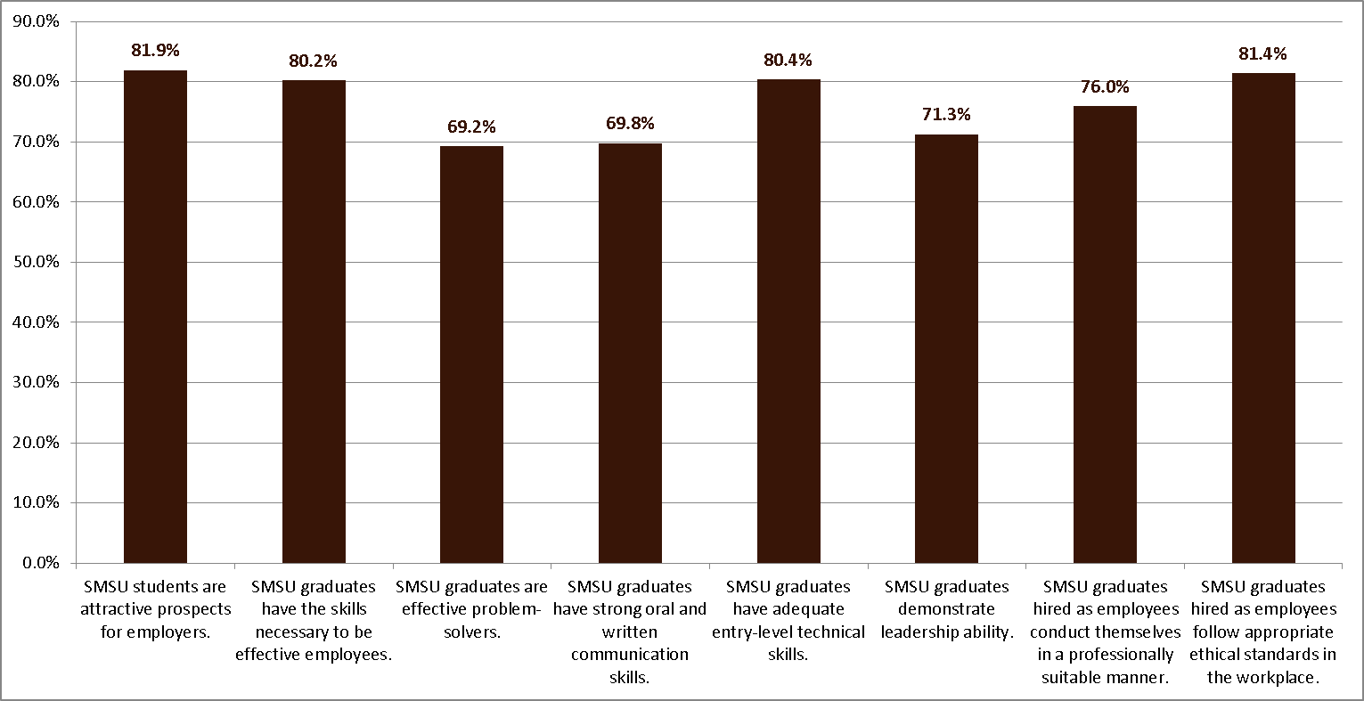

Likewise, alumni responded favorably when asked a question with some similar elements on their HLC Self-Study Survey. In response to the question “In what areas did your experiences at SMSU prepare you well for the following workplace needs (check all that apply),” oral and written communication, problem-solving, and time and project management skills were the top choices.

Figure 4.x HLC Self-Study Survey Spring 3013 Alumni response to question “In what areas did your experiences at SMSU prepare you well for the following workplace needs (Check all that apply)”
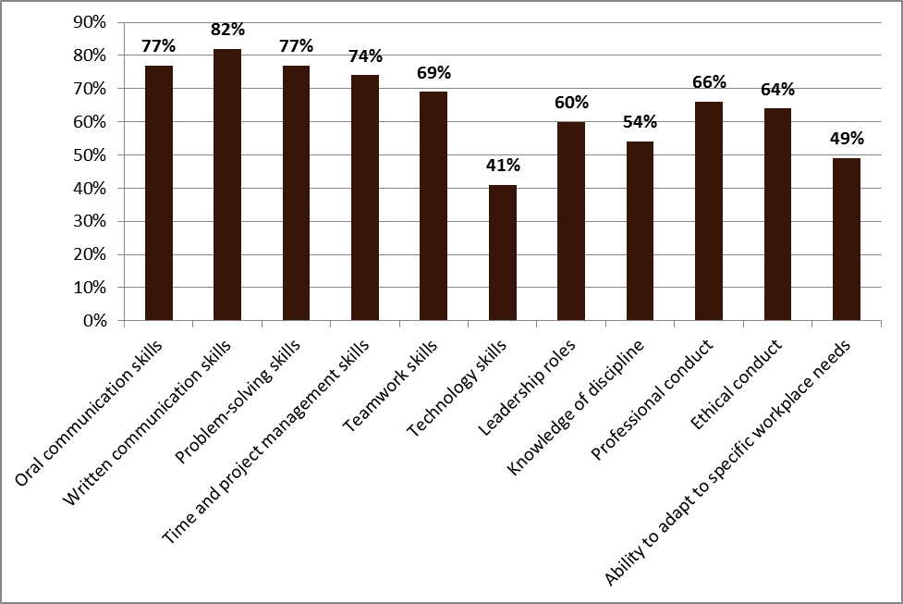

Core Component 4B. The institution demonstrates a commitment to educational achievement and improvement through ongoing assessment of student learning.

Assessment of student learning at SMSU occurs at four levels—the course, program, department, and institution, and draws from both direct and indirect measures of student learning. SMSU has a renewed commitment to assessment of student learning via a number of university-wide venues and activities.
SMSU has been experiencing a culture shift regarding assessment over the past ten years. Prior to the previous HLC review, members of the University community had come to understand that basic assessment measures should be based on outcomes and had made adequate progress in accordance with the expectations at that time. However, much of the assessment efforts still consisted of what Linda Suskie, author of Assessing Student Learning: A Common Sense Guide and former Vice President of the Middle States Commission on Higher Education who visited SMSU in early 2012, would term a “traditional approach,” in which assessments are planned and implemented without clearly defined course goals or learning outcomes, and learning tends to be judged primarily by the individual student’s course grade. Though progress had been made leading up to the 2004 review, and a number of programs developed solid, ongoing assessments, many programs still struggled with cultivating appropriate outcomes or assessment measures.
Immediately following the 2004 review, focus shifted to the revision of the Liberal Arts Core. As described further below in Section 4B1/4B4, this had direct consequences for support of program assessment. With the development of the new LEP, however, also came an increased understanding of learning outcomes and outcomes-based assessment. The LEP was developed from a ground-up effort involving all faculty, starting with the identification of what the core learning outcomes that are at the heart of an SMSU education should be. (See Criterion 3B1 and 3B2 for a full description of this effort.) After five years, the process resulted in a new LEP curriculum approved by the faculty in April of 2009 that was implemented in Fall 2010. Once implemented, attention shifted to review and assessment of the LEP. At that time, program assessment, which had been ongoing in some programs but not all, came back into focus. In 2011, support for “contemporary” approaches to assessment as defined by Suskie became more evident, with growing acknowledgement that assessment be carefully aligned with program and/or course goals and student learning outcomes, be focused on thinking and performance skills, and use data to improve teaching and learning for all students.
Moving the campus to this contemporary approach has been part evolution based on the learning experience associated with the LEP and trends in the national dialogue on higher education, but also due to a reinvestment in assessment with a renewed Committee on Institutional Assessment (CIA) and the strong efforts of a faculty member serving as assessment coordinator since 2011 (with accompanying partial reassignment in 2012-2013) to help lead faculty efforts and provide support.
The institutional components related to assessment are described further in the following sections. Subcomponents 4B1 and 4B4 are clustered together in order to describe the goals, structure and methodologies, and support for good assessment practices. Discussions of assessment outcomes and examples of continuous improvement that arise from the goals and processes are then described in Subcomponents 4B2 and 4B3.

4B1. The institution has clearly stated goals for student learning and effective processes for assessment of student learning and achievement of learning goals.
4B4. The institution’s processes and methodologies to assess student learning reflect good practice, including the substantial participation of faculty and other instructional staff members.

Identifying Goals for Student Learning
The faculty body took responsibility for reviewing and revising the core liberal education goals, or outcomes, associated with the transformation of the LEP. Through this effort, ten outcomes that comprise the foundation of any student’s education at SMSU were identified and agreed upon, and the appropriate curriculum, encompassing the MTC general education transfer requirements as well as upper-level liberal education requirements, was designed around the outcomes. (See the full discussion of the LEP in Criterion 3B1/3B2.)
Remarkably, after providing support and infrastructure for assessment focused on defining and delineating the difference between assessment for determining student learning versus evaluating student learning through course grades, as of Fall of 2012, 71% of undergraduate programs and 33% of graduate programs reported having defined program and/or department goals. A number of these undergraduate programs also indicated that they were in the process of developing and articulating student learning outcomes (see t-drive, assessment folder, individual departments). By February of 2014, the percentage of undergraduate programs reporting having defined goals increased to 97%, with 82% of the 33 undergraduate major programs (counting all of Education undergraduate majors as one program and excluding the four new or re-established agriculture programs just approved in 2013-2014) having student learning outcomes, curriculum maps, and assessment plans. In addition to academic programs, the departments in Student Affairs have also begun to include learning outcomes, primarily centered around the ten LEP outcomes, in their assessment efforts. Samples of academic and Student Affairs programs’ learning outcomes and course maps can be found in e-resources for reviewers.
The work done to date and the future sustainability of assessment efforts rely on the infrastructure that has been established or reinvigorated, described in the following section.

Creating a Sustainable Assessment Structure
Over the past four years, efforts aimed at building a culture of sustainable assessment at SMSU have been developed, enhanced, and implemented. The following elements have contributed to fostering assessment at SMSU and will each be described in further detail:
- the Committee on Institutional Assessment
- the appointment of an Assessment Coordinator
- the establishment of the Liberal Education Committee and appointment of a faculty LEC co-chair
- a revised Student Affairs assessment model and process
- the reorganization of Data Management and Institutional Research
- University-wide efforts to raise awareness of assessment
The CIA and Its Trajectory
The CIA has been a standing University committee since 2001, prior to the previous HLC review. As noted in the 2004 self-study, its University-committee status was intended to denote the enduring and ongoing nature of assessment work and its importance at the University. The CIA was instrumental in preparing the University for the previous round of accreditation. (For a full history of assessment efforts and the CIA from 1993 through 2004, see Chapter 10 of the 2004 Self-Study Volume 1.) From 2001 to 2003, the CIA worked with another campus group established for the accreditation review, the University Service Assessment (USA) committee, to encourage assessment across campus and to provide mini-grants to support units’ efforts. During this time, in addition to its work supporting program assessment, the CIA decided to begin assessing components of the then-titled Liberal Arts Curriculum (LAC), and conducted a study of communication skills on campus.
A new provost was appointed in 2002, and he was charged by the President to reexamine and refocus assessment on campus. In 2003 he encouraged the University to participate in more nationally used survey instruments including the Noel Levitz and the NSSE surveys, and, recognizing that the LAC was soon in need of revision, desired to shift assessment methods of the LAC to focus on achievement of overall outcomes for a general education program rather than assessment results from individual classes. While the CIA had begun some of this type of work, the Provost visited the committee and asked them to cease their plans to move on to other LAC goals while his intended restructuring of assessment support took place. Reassigned time for the chair of the CIA was also eliminated. The Provost proposed a new “Professional Development Service Network,” an organizational structure in which one or more faculty members would have responsibility and reassigned time, in collaboration with the campus representative to the System-level Center for Teaching and Learning and with student support staff. This network was to help the University understand how to integrate assessment into ongoing teaching and learning activities as well as recognize the teaching and learning taking place in support areas. University resources were to be channeled into this Network, with the CIA and USA left responsible only for the mini-grant function. In addition, the Provost envisioned a new faculty oversight committee charged solely with reviewing the LAC.
The timing of this request and planned reorganization occurred in the months before the HLC review took place. Following that review, the University was indeed required to revise its LAC, and as described elsewhere in this chapter and report, an LAC Transformation Committee did indeed form and accomplished the goal of developing a new liberal arts foundational curriculum, the LEP. The Transformation Committee was then replaced by the Liberal Education Committee (LEC), the standing committee which operates today to provide oversight and assessment of the LEP (the LEC is described in further detail later in this subcomponent section).
The CIA, however, left without a clear charge or task plan, including the absence of mini-grants when that budget item was eliminated, essentially suspended its operation for several years. A number of committee members left the committee, and the committee did not meet at all for a year, and met only briefly the following year to debate possible purposes. The Professional Development Service Network also did not materialize in the manner which the Provost intended. Additionally, the Provost moved on from SMSU.
In 2009, Provost Weatherby requested the committee become active again. Chaired by then-Dean of ALS Lyn Brodersen, the committee worked to regain its footing and explored what data were available, identifying key findings in the 2004 and 2008 NSSE and the 2006 HERI reports. Findings from their work were reported at an all-university meeting. The following year the Provost charged the Dean with creating an institutional assessment plan by the end of the year. The CIA divided into subcommittees, with some members continuing work on reviewing data from surveys and others helping the Dean develop an institutional assessment plan. The Dean had received permission to base an SMSU assessment plan on a model provided by another university and undertook the bulk of the revision. Unfortunately, the Dean resigned at the end of the Spring term in 2011, and the assessment plan was not completed. However, the members of the CIA had developed a greater understanding of what elements might need to be involved in an institutional plan and were not satisfied with relying on a different institution’s model, as it had not proven to be a good fit.
The CIA has regularly met since 2011 and has continued to refine its charge. In 2011-2012, the committee was co-chaired by the Dean of ALS and a faculty member, who went on to be appointed as Assessment Coordinator. Reassigned time of six credits for the academic year was provided again for the coordinator/co-chair position beginning in Spring of 2012. Previously, the CIA was comprised only of faculty representatives from each academic department, but the charge was re-examined by the committee in spring 2012 to ensure that all operational areas were represented. Consequently, the co-chairs invited other areas including the other bargaining units to appoint a member to serve on the CIA. The CIA now has members from the faculty and other instructional and organizational units including Student Affairs and support staff (http://www.smsu.edu/administration/committees/cia/). Another significant change in the CIA was adding the Associate Vice President of Student Affairs to the committee in order to foster and strengthen curricular and co-curricular student learning experiences.
The CIA has spent significant time exploring what an institutional model for assessment should look like at SMSU, its version of an institutional assessment plan. A committee member developed an institutional assessment flow chart, based on his disciplinary lens of chemistry. The chart, represented in Figure 4.x, is based on a model of inputs, reactants, and products. Each of the elements represented on the chart has been operational since 2009 in the case of the LEP or earlier, such as the CIA and Strategic Planning. The flow chart demonstrates how information should be distributed, reviewed, and used by the different entities involved in the different levels of course, program, and institutional assessment at SMSU. [NOTE: will get updated version and not screen-capture picture in final version of self-study]

Figure 4.x SMSU Institutional Assessment Flowchart
Several CIA members and the Provost presented on the flow chart at the 2013 HLC Conference. As the Provost noted in her presentation, “Perhaps the most difficult parts of creating an assessment plan that encompasses an entire institution are mapping the relationships among such a large number of moving pieces and then devising a way to communicate that every piece impacts all of the other pieces,” adding that the flow chart “has the advantage of clearly communicating that assessment is everyone’s responsibility.” Although still in the developmental stage, the flow chart is an attempt to link academic program assessment with the university’s strategic plan and other non-academic areas. Now that the CIA has identified and mapped all of these moving parts, the committee is working out the best methods for achieving the communication and reporting goals described in the chart, in order to ensure that assessment is not just being talked about but is resulting in continuous improvement.
In addition to their work on the institutional assessment model, in Spring 2012, with funds allocated by the administration, the CIA re-instituted assessment mini-grants after a hiatus of nearly 10 years. The mini-grants of $200 to help with items such as supplies, meeting incentives, and student help encourage academic faculty and programs to engage in assessment of courses and academic programs. Eight assessment mini-grant projects were submitted to the CIA in Fall 2012. In FY13, four more programs applied for grant money [UPDATE WITH 2014 NUMBERS]. Although the grant funds were small, they were enough incentive for programs to set aside time to meet and discuss program goals and develop (some for the first time) student learning outcomes, a program course map and a 3-5 year assessment plan. Programs who received these grants made substantial progress in the development of the program’s overall assessment plan. Recognizing the need to include all levels of the institution in assessment, assessment mini-grants were extended to include all SMSU staff in Spring 2013. The first non-faculty assessment mini-grant was submitted by an administrative assistant whose proposal aimed to engage all administrative assistants in helping faculty report and showcase their program/department’s assessment activities. It is the intention of the CIA to continue offering assessment mini-grants on a regular basis following the 2014 HLC visit, thus promoting an ongoing culture of assessment at SMSU. More information on the grants can be found on the CIA website (http://www.smsu.edu/administration/committees/cia/?id=8344), and a listing of all mini-grant applications and the grant reports from recipients can be found in e-resources as well.
In addition to the mini-grants, the CIA has also promoted assessment and educated University members about assessment through a variety of other means. More information about these efforts are described later in this section.
Assessment Coordinator
As noted above, the administration approved the formation of an assessment coordinator position in 2011-2012. The assessment coordinator serves as co-chair of the CIA. The reassignment of a faculty member into this position supports the ground-up approach to academic assessment that has been successful in helping faculty come to view assessment as under their control rather than being dictated from above. The assessment coordinator has been instrumental in organizing professional development days focused on assessment, providing information and templates to all departments and programs, and coordinating assessment efforts with the LEC and communicating with the Strategic Planning committee.
The assessment coordinator created a guide for programmatic assessment, based on readings and templates from a number of sources, called “Creating a Plan for Assessment of Student Learning (PASL) at SMSU.” The development of the plan was in response to faculty requests for guidance in constructing student and program assessment measures and plans. The templates found in this plan were the basis for an assessment day activity and create the foundation for what is expected in departmental assessment files. The coordinator, with the help of the CIA, also developed an assessment file documentation checklist for departments.
In December 2011, the assessment coordinator applied for and was awarded a Minnesota State Colleges and Universities (MnSCU) Campus Faculty Development Project Grant. The grant, entitled “Building a Sustainable Commitment to Assessment of Student Learning at SMSU” (see t-drive, HLC criterion 4B3), proposed to support and promote assessment efforts by retaining the services of a nationally-recognized assessment consultant to assist SMSU in developing a framework on which to build a sustainable, institutional commitment for assessment of student learning. Linda Suskie’s visit to SMSU on January 26, 2012, was the additional incentive the institution needed to reinforce its assessment activity not only at the level of academic departments, but across the entire university. Her visit schedule is available in e-resources.
The LEC and Its Role in LEP Assessment
As described above in the history of the CIA, a separate oversight body (the Liberal Education Committee, or LEC) was formed to handle responsibilities related to the new LEP. This group took the place of the LAC Transformation Committee, who led the development of the revised program. The committee is co-chaired by a faculty member reassigned 50% to the position for a three-year term and by the Dean of ALS. The faculty reassignment is a continuation of support that was provided to the LAC Transformation Committee chair. The CIA faculty co-chair and LEC faculty co-chair work closely together along with the HLC Self-Study Coordinator to ensure that faculty are aware of and have multiple opportunities to participate in academic assessment activities.
The LEC is a University committee, with representation from the Educational Opportunity program in addition to IFO faculty and participation from Student Affairs as needed. The committee is charged with the following:
1. Initiation and review of curriculum proposals for the LEP/MnTC. Proposals will be reviewed by the LEC and forwarded to the Curriculum Committee with recommendations.
2. Oversight of IDST 100: First-Year Seminar (FYS). The LEC will approve sections, coordinate schedules, and offer instructors’ meetings.
3. Oversight of IDST 400: Contemporary Issues Seminar (CIS). The LEC will approve sections, coordinate schedules and offer instructors’ meetings.
4. Implementation of curricular and co-curricular activities that foster achievement of the 10 LEP outcomes throughout a student’s educational experience.
5. Assessment and assessment planning for the 10 Outcomes of the LEP. Two outcomes will be assessed each year on a five-year rotating cycle.
6. Communicate and collaborate with university administration, faculty, and staff on all aspects of curriculum, assessment, advising, and co-curricular activities that relate to the LEP.
The full text of the committee’s charge and make-up can be found at https://www.smsu.edu/administration/smsufa/?id=7833.
After several years of intense work reviewing curriculum as the revised LEP took root, the LEC has focused efforts on assessing the LEP outcomes. Information on the methods and progress made to date in these efforts is described in Criterion 4B2/4B3. Of note here is that, following the advice of a national consultant, the committee has established an assessment plan that puts LEP assessment on a three-year cycle rather than a five-year cycle as described in the charge above.
Student Affairs and Co-Curricular Assessment
As indicated in the sections above, efforts have been made in recent years to broaden the scope of the CIA and LEC committees to include Student Affairs directly in the discussions about academic assessment.
The Associate Vice President for Student Affairs has supervisory authority for nineteen departments: academic and diversity resources (AOS), career services, conference and event services, counseling and testing, cultural diversity, disability resources, hazardous materials, health services, international student services, residential life, retention office, scheduling, student activities, student center, student government, student judicial affairs, campus bookstore, child care center, and dining services.
Although many of these departments have been collecting data over the years, assessment activities have been ramped up over the years since the last HLC review. Prior to the professional development days of August of 2012 and February 2013, the co-curricular assessment activities were conducted on a one-on-one basis with the department directors and the Associate Vice President for Student Affairs. From 2004-2005 through 2008-2009, each department would produce a document that would contain its goals for the academic year. Then at the end of the academic year they would produce the accomplishments from that set of goals. The first several years of the Goals and Accomplishments process the end results were very positive, but outcomes were not well documented. Beginning in the 2009-2010, departments were asked to add what the next steps would be from these results. A more formal assessment plan within the Student Affairs departments continued to evolve. In 2011, the Associate Vice President for Student Affairs began a coordinated effort with the Assessment Coordinator and the Office of Institutional Research to develop a comprehensive, outcome-based assessment program for the division of Student Affairs. Other catalysts which aided in refining the assessment planning and reporting process included commenting on assessment activities as part of the directors’ annual evaluation; dedicating one directors’ meeting per semester to assessment strategies; identifying assessment consultants to assist with outcome formulation and instrument design; and the utilization of consistent reporting template(s) to organize the annual assessment activities and report.
In order to assist the department directors in the assessment process, an assessment reporting template has been developed that each Director and department will follow. These templates will be assembled at the end of each academic year to form a Year End Report for the Division of Student Affairs. Each Department’s assessment plan includes six components: mission statement, planning goals, program objectives or student learning outcomes, methods and measures, findings, and conclusions/status. A copy of the template instructions can be found in e-resources. The expectation is that each director, in conjunction with his/her staff, will formulate at least four student learning outcomes or program objectives related to departmental mission, goals, and division/university priorities. At least one of these outcomes must be “student learning”-oriented with measurable outcomes. The outcomes are to be tracked and reported on during the course of the year.
To help Student Affairs’ staff understand the new approach and learn about outcomes-based assessment, a professional development workshop led by an external consultant who provided assessment examples and guidance was held in August 2012 A second workshop was held in February of 2013 to follow up on departments’ planning and questions. The transformation from a program improvement model to a student learning based program model has progressed smoothly. As with any newly developed model, Student Affairs will learn with each assessment and continually update the model.
Other areas not overseen by Student Affairs structure their own assessment plans and report to their supervisors through the appropriate mechanism. For example, information from Academic Commons is provided to the Dean of ALS; the Writing Center reports on its assessment efforts via the Director’s contribution to the English Department’s annual department report; and the Center for Civic Engagement houses on its site an annual report of findings from the Civic Engagement Survey, conducted as part of the campus clearance process for graduating students and analyzed by professors working with the Center.
Reorganization of Data Management and Institutional Research
Another helpful component in creating infrastructure that supports sustainable assessment has been the reorganization of what had previously been the Office of Research and Institutional Grants (RIG) into a new office titled “Data Management and Institutional Research” (DMIR). (This reorganization is also described in Criterion 3A1 “Curriculum Design and Review Processes.”) Following the retirement of the RIG director in 2005, the University took the opportunity to reconfigure how data was processed and managed. The University opted to create a Chief Information Officer position to lead RIG’s functions and future information technology services planning and operations. Concurrently, the previous Computer Services department was reorganized into a new Information Technology Services division. The DMIR office was created within Information Technology Services and an Interim Director of Institutional Research and Reporting was named during the 2007-2008 academic year; the interim director has since been replaced with a permanent hire. The Director himself now reports to the Provost. The office is also staffed by two Database Programmer/Analysts who constitute the Data Management group and report to the Chief Information Officer.
The DMIR office provides data analysis, reporting, planning and policy support, and assessment data to the University. These DMIR personnel manage a data warehouse of snapshot data that encompasses student enrollment, demographic, course, and outcome data. Moreover, they work in coordination in analyzing important variables such as graduation rates, numbers of majors and minors, numbers of students enrolled, numbers of full time equivalent (FTE) students at the University, etc. Since 2004, the DMIR office has worked hard in creating an edited and cleaned longitudinal dataset that is the source for Factbook, program review, enrollment reports, and ad hoc requests. Additionally, the DMIR office is available to departments and programs to assist in evaluating data, presenting data in alternative formats, and performing statistical manipulation.
Beginning in 2009, the DMIR group began transitioning from the publication of an annual “Datum” and toward online dissemination of University recordsets. Currently, this online repository (http://www.smsu.edu/administration/datamanagementinstitutionalresearch/) houses reports encompassing Enrollments, Degrees Awarded, Admissions, Retention, Tuition and Financial Aid, and Facilities. Student Engagement data from NSSE is also available online, as well as Program Analysis and Review data. Beginning in 2012, these offices began providing day-to-day reports on enrollments during registration and beginning of semesters as a more efficient means of transmittal to administration, faculty, and staff.
All of these reports are available to the University and public at large for analytical research, question answering, and information. Offices and programs from across the University can access these datasets and integrate them into their strategic planning and budgeting processes. This easy access to information leads toward more effective management of the operations of the University. Even with improved distribution via the internet, knowledge of and usage of online data still can improve. As such, training and knowledge sharing during professional development and strategic planning days continues to be a point of emphasis.
Surveys as a source of information at SMSU have evolved in the past decade. NSSE surveys have become a MnSCU-required instrument on a bi-annual basis. Usage of this instrument remains a work in progress. Since 2008, NSSE has been administered three times, so a useful historical reference is beginning to come into focus. Graduating student surveys, known as the Senior Survey and described earlier in Criterion 4A6, continues, but is a survey data set that is generally understood to require review and updating.
Increasingly, the University has been making use of online survey tools to quickly create and send a survey on a very topical area. These online surveys run the gamut from alumni surveys for programs to quick studies of student’s summer school plans. These tactical surveys can be short and to the point and can be put into decision-making hands quickly. Similarly, the DMIR office is working with the Office of Student Success on developing an analysis of that office’s exit survey. This project is part of a larger project involving student retention and persistence.
Beginning in Fall 2010, SMSU began a process shift in how to meet the needs of enrolled students. One part of that process was the collection, analysis, and use of retention data to better examine why students do or do not remain at the institution and then determine how the institution can be more effective in increasing retention. More information on retention can be found in Criterion 4C.
Efforts to Raise Awareness of Assessment
In addition to mini-grants, all of the entities described above have been active in raising awareness and providing ongoing training related to assessment. As shown in Table 4.x, the list of varied activities over the past three years demonstrates the investment of the campus community in assessment. Table 4.x lists faculty and Student Affairs’ professional development days, workshops, calendared assessment work time, Lunch and Learn presentations sponsored and organized by the CIA, and all-University strategic planning sessions that involve assessment.
Assessment of student learning was the theme for faculty professional development days beginning August 11, 2011 (see t-drive, HLC criterion 4B3), which highlighted HLC criteria and evidence of student learning needed for our HLC accreditation self-study. The day’s activities focused primarily on assessing the First Year Seminar course, a key part of the newly-implemented Liberal Education Program. “Building a Sustainable Commitment to Assessment of Student Learning: Mapping the Way to a Program Assessment Plan” continued as the theme for January 2012’s professional development day activities. The day featured reports from HLC criteria teams and segued into a basic “how to create an assessment plan” for academic programs.
Program and institutional assessment were the topics for August 22, 2012, professional development in a concerted effort to underscore to faculty the importance of assessment of student learning (see t-drive, HLC criterion 4B3). Since the August 2011 focus on assessment, there have been numerous requests from faculty for more information about and guidance through the assessment process, and dedicated time to do assessment. Both requests were honored. As further evidence of administration’s commitment to promoting a culture of assessment at SMSU, a designated assessment day (September 19, 2012) was added to the academic calendar for the first time in SMSU’s history. An assessment day (Feb. 20, 2013) was also calendared for Spring 2013 and called Planning and Assessment on the Spring 2014 calendar. The Spring 2014 time focused primarily on planning for the budget shortfall.
The Lunch & Learn presentations (L&L’s), one-hour informal sessions that feature a topic related to campus assessment instituted by the CIA, have also helped to create a culture of ongoing assessment. The general purpose of the L&L’s is to inform the campus community of assessment-related activities across the campus; assessment is purposefully being defined broadly, with a wide range of topics that demonstrate the different ways in which campus constituents are engaged in assessment and continuous improvement, even if they would not use the term assessment. (See e-resources for a list of Lunch and Learn topics.) L&L’s are open to faculty and other interested SMSU staff. Although attendance at most Lunch &Learns has been modest, ranging from 20-40 attendees, each session draws in a variety of people from across campus.
Further evidence that faculty are accepting of assessment comes from evaluations of these faculty professional development and assessment days. Faculty response has been very positive as seen in the following comments: “I found our assessment session in the afternoon very helpful. We made great progress, and we appreciate having this time set aside to focus on assessment,” and “[The] most useful was the time to actually work on Assessment within programs.” The assessment mini-grants and Lunch and Learn topics serve to reinforce assessment mindfulness regarding assessment, not only with faculty, but with staff as well.
With the renewed commitment to institutional assessment, administration, the assessment coordinator, and the LEC co-chair have discussed the best approach for continued support for assessment efforts on campus. Ideas for a part-time staff position, student support, or a full-time assessment position had been discussed in the past. However, with the budget shortfall, no additional resources are likely able to be funded, and the current assessment coordinator and LEC co-chair may have to reduce their reassignments. The assessment methods now in place have positioned departments and programs fairly well to continue to move forward.

Table 4.x Faculty and Student Affairs Professional Development and Assessment Activities, 2011-2014

Date | Activity | Topics/Outcomes
Aug 17, 2011 | Faculty Professional Development Day | “Building A Sustainable Commitment For Assessment Of Student Learning” Presentation of HLC criteria and need for assessment data; review of LEP assessment data; discussion of speech communication rubric for use in LEP.
Jan 5, 2012 | Faculty Professional Development Day | “Building A Sustainable Commitment For Assessment Of Student Learning: Mapping The Way To A Program Assessment Plan” update of HLC self-study; discussion of components of academic assessment plans; mapping student learning outcomes.
Jan 26, 2012 | Campus visit by accreditation and assessment consultant, Linda Suskie | Report entitled “Observations And Recommendations On Assessing Student Learning At SMSU Based On A Visit, January 25, 2012”—provided foundation for promoting sustained assessment at SMSU
Feb 15, 2012 | Strategic Planning Day, campus-wide | President Wood seeking campus input regarding updating SMSU Strategic Plan; assessment of academic programs and LEP represented as goal of “Academic Strategic Direction”
Feb 29, 2012 | LEP outcomes workshop | Discussion of examples of assessment for outcomes per each of ten LEP goals; Began developing plan to assess outcomes.
March 20, 2012 | LEP outcomes workshop | Finalized Assessment Plan related to outcomes for each of ten LEP goals
Aug 9, 2012 | Student Affairs Professional Development Day | Development of formal assessment plan within student affairs department; individual programs will report on assessment activities in spring 2013
Aug 21, 2012 | Faculty Professional Development Day—  Part I | President Wood introduces new Program Analysis System (PAS) which provides data on cost of academic programs; academic programs/departments meet to review their own data.
Aug 22, 2012 | Faculty Professional Development Day—  Part II | “On Our Way… Building A Sustainable Commitment For Assessment Of Student Learning;” HLC and LEP updates; CIA assessment mini-grants information; continued work on SMSU Academic Programs Assessment Documentation Checklist
Sept 19, 2012 | Faculty Assessment Day | First Year Seminar (FYS) updates; Assessment mini-grants information; Programs continued work on SMSU Academic Programs Assessment Documentation Checklist; faculty request to share examples of course/program assessment. Faculty note value of dedicated time in academic calendar for assessment activities.
Oct 18, 2012 | Lunch and Learn (sponsored by CIA) | “A Focus On Contemporary Issues Seminar—Where Do We Go From Here?” (Discussion of assessment measures for LEP 400)
Nov 1, 2012 | Lunch and Learn  (sponsored by CIA) | Assessment mini-grant recipients presentation of how assessment activity informed program faculty
Jan 10, 2013 | Faculty Professional Development Day | HLC and LEP updates; Programs continued work on assessment plans; faculty request to share examples of course/program assessment. Faculty note value of dedicated time in academic calendar for assessment activities.
Feb 6, 2013 | Student Affairs Professional Development Day | Departments discussed and compared assessment plans; set assessment goals for next year.
Feb 7, 2013 | Lunch and Learn  (sponsored by CIA) | “Advising For The LEP: Are The Rules Working?” (review of data on how well students are moving through LEP 100 and LEP 400)
Feb 20, 2013 | Faculty Assessment Day | Examples of faculty assessment presented; programs engaged in on-going assessment discussions.
Feb 21, 2013 | Lunch and Learn  (sponsored by CIA) | “Guide To SouthwestNet: Instructions And Best Practices For Editing Your SMSU Webpage”
Oct. 23, 2013 | Lunch and Learn  (sponsored by CIA) | “Civic Engagement At SMSU: ‘Being The Change’”
 | [UPDATE THROUGH | END OF SPRING 2014]

4B2. The institution assesses achievement of the learning outcomes that it claims for its curricular and co-curricular programs.
4B3. The institution uses the information gained from assessment to improve student learning.
Results of course, program, and institutional assessment of student learning provide an important basis for program improvements. Assessment practices across campus include direct and indirect methods such as end-of-course questionnaires completed by students; surveys of students’ reactions to selected aspects of courses (such as lectures, assignments, the professor’s attitude, level of preparation, etc.); pre- and post-tests; review of students’ ability to synthesize and integrate subject matter in capstone courses; review of student portfolios; review of videotaped student performances; juried reviews of student work; evaluation of students’ performance on research papers and/or oral presentations in capstone courses; informal and formal conversations among faculty concerning levels of student achievement in cumulative major courses; and many others. Institutional measures of student learning via nationally available tools such as NSSE and CAT are also available to identify areas of concern or strength regarding student learning. NSSE data: NSSE 2011 report can be found at https://www.smsu.edu/administration/datamanagementinstitutionalresearch/nsse/nsse11%20benchmark%20comparisons%20report%20%28smsu%29.pdf. [UPDATE to 2013 soon]
In every department or program, collection of information is followed by integration of that information into the cycle of review of classes, courses, and curricula and leads to changes that further encourage and support student learning. This integration can take the form of revising course materials to meet student expectations and improve student performance, devising alternative means of presenting information to students, involving students in active learning, and encouraging student participation in service learning. Assessment has resulted in changes in the sequence of courses in majors, changes in the overall structure of majors, and changes in major requirements, all designed to insure that valued student outcomes are being achieved.
Specific examples from LEP assessment, academic program assessment, and co-curricular assessment follow below.

Liberal Education Program assessment
Considerable time and effort has been devoted to assessment of the LEP since its debut in Fall 2010; prior work on assessment as the program was being developed is documented in the two progress reports on general education submitted to the HLC in 2007 and 2009 (available on the SMSU HLC website https://www.smsu.edu/administration/hlc/). While initial assessment efforts focused on LEP 100 First Year Seminar and LEP 400 Contemporary Issues Seminar, the two bookend courses of the LEP curriculum, one of the most important and immediate examples of assessment activity has been the development and implementation of an assessment plan for the overall LEP. Faculty and administration recognize that the on-going task of assessing the LEP will be successful only if faculty are involved and drive the process.
Initial Assessment of LEP 100 and Critical Thinking
After the first semester of courses in the revised LEP were offered, the LEC focused initial assessment efforts on LEP 100 First Year Seminar. The Faculty Assembly had had difficulty coming to consensus regarding the critical thinking outcome’s objectives and placement in the curriculum. With almost all entering freshmen required to take this new course, the LEC wanted to determine how well the intended curriculum was operating programmatically in addition to accomplishing the critical thinking outcome associated with the course. The LEC and LEP 100 instructors have already made several improvements to the course and assessment measures. The LEC reviewed a variety of tools used to assess critical thinking. SMSU had participated in a trial of the CLA exam with other MnSCU institutions but did not feel the test accurately measured critical thinking as outlined in the SMSU objectives. The LEC decided to pilot the CAT exam, the results of which are described in the LEC report on the CAT available in e-resources. Overall, the results of the pilot study indicate some, albeit modest and inconsistent, evidence of improvement toward the critical thinking outcome of FYS students at SMSU. However, after several administrations of the test and comparison of what the test measured to how critical thinking is discussed and taught in the LEP sections, the LEC determined that the CAT exam was not the best instrument. The CAT focuses heavily on inductive reasoning and not the deductive reasoning and argument analysis that many of the FYS instructors teach in the class, per the SmSUFA-approved approach to critical thinking. The committee has now decided to require an adapted Ennis-Weir letter method in each section; this measure is a better match with the curriculum. The use of this method was first required in all sections in Fall 2013. The results from this approach indicate …. [NEED ASST RESULTS/DATA TABLE HERE WHEN ANALYSIS OF 13-14 IS COMPLETE]
In addition to the direct critical thinking assessment measures, the course has been reviewed by faculty in several other ways, including analysis of the course’s other learning objectives related to information literacy and adapting to college. LEP 100 First Year Seminar (FYS) and the Contemporary Issues Seminar (LEP 400) were the topics of Assessment Day activities in Fall 2012. The LEP 100 session focused on discussion of the core concepts/principles to include in course and assessment measures and assignments that faculty would use to assess critical thinking (see t-drive, HLC criterion 4B1). Instructors of LEP 100 also meet several times as a group each semester to discuss what methods and approaches seem to be working well that can be shared with other sections. [LIST OF DATES FROM WILL] The ongoing review and instructor meetings resulted in an Instructors’ Manual for LEP 100, produced by the LEC and approved by SmSUFA in February of 2013 [link]. At the end of Spring 2013, a special one day workshop for LEP 100 instructors (current and those interested in teaching it in the future) was led by the LEC to conduct training on critical thinking and to establish shared approaches to the information literacy component of the course [link to day’s agenda].
The outcome related to adapting to college and how much time can be devoted to this outcome was one of the key points discussed in spring of 2012. In Fall 2011 and Fall 2012, President Wood initiated a special retention pilot project, a free one-credit course intended to connect students closely with faculty and a small peer group called “Building Connections.” This course was offered to a small, randomly selected group of “middle class” freshmen, students who were not admitted provisionally, yet not honors students. A report on this project [link] was shared with the LEC in Spring 2012 in order to explore how the course or best practices from the course could be incorporated into LEP 100 for all students. While the conclusion of the LEC after reviewing the methods and data was that the entire course could not be subsumed into LEP 100, the activities were shared with the LEP 100 instructors as suggested engagement activities.
Now that LEP 400 has been offered for several years, the LEC is engaging in a similar process of reviewing the course, starting with bringing together those who have taught it for their feedback. The LEP learning outcome focused on in the course, creative thinking, is slated for assessment in 2013-2014.
The LEP Assessment Plan for All Ten LEP Outcomes
In addition to the assessment work on critical thinking and LEP 100 described above, the faculty and the LEC spent several years developing a final assessment plan for all ten LEP outcomes. The plan was approved by SmSUFA and through the Meet and Confer process in February of 2013. [link here] As noted earlier, the assessment cycle outlined in the plan enables review of all ten outcomes every three years rather than every five. While ambitious, the more frequent review was put in place after Dr. Linda Suskie’s visit to campus, in agreement with her counsel that five years is too long to wait to see how/if improvement efforts from a previous assessment are making positive differences. In addition, the plan states that an outcome could be reviewed more frequently than every three years if needed. Each year, three or four of the LEP outcomes will be assessed, led by an Ad Hoc Assessment (AHA) team, which is co-chaired by a representative from the LEC and from the CIA. The remaining membership consists of one member from Student Affairs and faculty members who teach courses in the outcome area to be assessed or from the faculty at large, for a total of 4-6 team members. The rotation cycle will repeat every three years; Table 4.x demonstrates the first cycle:

TABLE 4X PLANNED SCHEDULE FOR OUTCOME ASSESSMENT

Academic Year | LEP Outcomes to Be Assessed
2013-2014 | 5. Physical and Social World; 6. Diversity; 8. Citizenship
2014-2015 | 2. Communication; 3. Creative Thinking; 4. Critical Thinking
2015-2016 | 1. Disciplines; 7. Moral; 9. Life-long Learning; 10. Mind, Body, Spirit

The AHA teams actually work over a period of 18 months, assembling towards the end of one academic year, working through the next year, and reporting out at the beginning of the following year. Thus, each year there is some overlap as new AHA teams begin while the work of the prior teams is finishing up. The AHA Team calendar is as follows:
- Mar. 31: SMSUFA names members of each AHA Team
- Apr. 30: Each AHA Team identifies outcomes, courses and methods
- Following fall and spring semester: Each Team collects data
- Sep. 30: Each AHA Team reports to the LEC
- Oct. 31: LEC reports to SMSUFA
It is up to each AHA team to determine which sub-goals of the outcome to assess; the co-chairs’ knowledge from their work on the LEC and CIA committees should help inform the team about the strategic priorities and assessment history related to each learning outcome. Each of the first AHA teams for all ten outcomes is receiving a duty day of pay in order for the teams to gather at the end of spring semester to make plans for data methods and collection over the course of the next year. Ideally these teams are establishing baseline practices that future AHA teams can follow when the LEP outcome comes up again for assessment review. The first AHA teams’ reports to the LEC will be available at the time of the HLC review team’s visit, along with a summary of the second teams’ plans.
En route to the final LEP assessment plan, several key efforts helped move the process forward. One of the first efforts was the establishment of common rubrics for the four core skills of oral communication, written communication, critical thinking, and information literacy. (Each of these finalized rubrics can be viewed on the LEC’s website http://www.smsu.edu/academics/liberaleducationprogram/?id=6070.) While the rubrics were passed by SmSUFA in 2011-2013, with the critical thinking rubric the final one in Spring of 2013, each of them had been worked on initially during the development of the LEP outcomes; for example, the first draft of the critical thinking rubric was discussed at an all-University meeting in October of 2008 during the construction of curriculum phase. The early discussion during the LEP formation process helped faculty identify a common understanding of the core skills and enabled them to see how the core skills could be measured in any class or program. The direct utility of the rubrics remains a work in progress. The English Department uses the Written Communication rubric to conduct program assessment of their LEP writing courses, as does the Speech Department with the Oral Communication rubric and its SPCH 110 course. Other program areas have adapted the rubrics for use when evaluating student performance. [NEED EXAMPLES] As the AHA teams conduct their work, the rubrics are tools that are at their disposal.
A second effort that proved very helpful in engaging the entire faculty in the LEP assessment process were two large-scale brainstorming workshops held by the joint efforts of the LEC and CIA. The LEC and CIA held two meetings in February and March of 2012 for faculty who had taught or were interested in LEP classes in any of the ten goal areas and asked them to help design what the assessments could/should be for each goal area. The meetings involved one or two facilitators from the LEC who directed the discussion based on a specific set of instructions and questions for the group to address, so the group’s task was clear and manageable. Each group had an Assessment Plan Handout for each LEP goal that they were tasked with completing. Approximately 32% (N=110) of faculty volunteered to participate in the LEP assessment workshops. The workshops successfully resulted in potential, specific assessment methods for each of the ten LEP goals (see assessment—CIA, LEP file). A draft of each group’s Assessment Plan was sent to the LEC, who consolidated the ideas and looked for common instruments or other useful overlaps. The assessment plans were then shared with SmSUFA Executive Committee for their review and feedback. The final version is being distributed to each of the AHA teams for their use.
Important to note regarding the cycle of LEP assessment above is that assessment of some of the outcomes is already ongoing within departments and other entities. For example, the Biology Program assesses its LEP courses, and thus the “Physical World” learning outcomes related to LEP goal 5 (link to sample report). Data related to the “Citizenship” outcome is gathered yearly via the “Civic Engagement Survey” as part of the campus clearance process for graduating seniors. In addition, SMSU administers NSSE on a regular basis, 2004, 2008, 2011 and 2013, along with Campus-Community Inventory of Civic Engagement (2004, 2009), and HERI Faculty Survey (2006) (insert links to reports). Data from all three surveys provides a national reference point regarding civic and community engagement. The English Department has created a cycle of review of its LEP writing courses and conducted portfolio review of random samples from several of those courses. Numerous programs review how well their introductory courses contribute to a baseline understanding of their disciplines in their program reviews. In other words, the AHA teams’ work will not be conducted in a vacuum, but will identify and mine assessment practices from across campus to assemble a larger understanding of how the ten LEP outcomes are being met and addressed not only in core LEP classes but across the curriculum and co-curriculum.

Academic program assessment

SMSU bases its academic assessment on the achievement of student learning outcomes. SMSU’s efforts to utilize assessment results are exhibited in a number of ways. For example, course-level learning outcome results may be used by individual faculty for improvements in course delivery and content. Programs may also use course-level learning outcomes to assess student learning of key concepts for a particular academic major or minor. Periodic review of data, especially as related to the five-year program self-study cycle, also provides evidence regarding student learning that informs decision-making and continual change. As described in Criterion 4A1, these assessment results are subject to external scrutiny via each program’s external consultant. The consultant’s recommendations combine with the program’s reflection, culminating in a five-year plan for improvement. Data in program reviews can include portfolio assessments or other direct measures of learning outcomes such as pre-and post-tests, NSSE and Senior Survey results, alumni surveys, employer surveys, graduate school acceptance data, enrollment, retention, and completion data, feedback from internship mentors or other partnerships, or other materials as appropriate to a program’s goals. While not all data is necessarily directly related to specific learning outcomes, faculty in the program scrutinize the findings, looking for areas and learning goals in which students excel as well as where more focus or attention might be needed and outline strengths and concerns in the program’s self-study.

As noted earlier, strong efforts, led by faculty helping other faculty, have helped programs identify learning goals, map these goals to courses, and create assessment plans. A few departments are still struggling to accomplish each of these steps, but newer programs, such as Professional Writing and Communication and RN-to-BSN, have been developed with an awareness of the importance of assessment from the beginning. [link to their assessment plans] As stated in Criterion 4B1/4B4, one measure of identifying the progress of programs is reviewing what has been posted onto the t-drive assessment file space. Even this is difficult because of the variability in language used by programs, making it hard to identify and quantify. While this may be an incomplete account, as several programs claim to have additional assessment materials than posted there, as of February 2014, 82% of the 33 undergraduate major programs (counting all of Education undergraduate majors as one program and excluding the four new or re-established agriculture programs just approved in 2013-2014) have student learning outcomes, curriculum maps, and assessment plans. 97% of these programs have department or program goals. See “SMSU Academic Programs Assessment Documentation Checklist” [link here] for the complete list and additional information.
On-going assessment by programs is reported in departmental annual reports and program review self-studies (department reports are consolidated into college reports, the most recent of which are publically available on the Deans’ website: http://www.smsu.edu/administration/academicdeans/?id=3780; see also Criterion 4A1). The reports reveal that programs are in different stages of assessment, with some programs having fully embraced assessment for many years with strong data sets and a history of evidence-based decision-making, and other areas that are in process of creating stronger programmatic assessment plans. For example, some programs have program goals but assessment methods are still centered primarily at the course level with traditional student evaluation methods. However, those programs have been working to assemble broader programmatic assessment, especially as they engage in program review self-studies. Other areas have identified new methods for achieving programmatic assessment but are in the process of instituting the changes. For example, the Accounting program notes in its report the success they have had in moving from identifying goals and developing a plan to instituting the changes needed to enact their plan. They have established two new additions that will enable them to conduct assessment of their program’s learning goals: a senior exam that beginning in the 2013-14 academic year, and a student learning portfolio beginning with the 2014-15 academic year, in which students must demonstrate fulfillment of the program’s goals.
Programs with a strong history of assessment include Education, Environmental Science, Sociology, Biology, Chemistry, Speech Communication, and Psychology. The Education Department has long had to demonstrate assessment results in order to provide teacher licensure programs accredited by the Minnesota Board of Teaching. The assessment plan for undergraduate programs includes review of students’ portfolios using Livetext ratings for both student and program assessment. All graduate Education programs also include an Action Research Project and a graduation portfolio requirement. During the last review of graduate Education programs by the Minnesota Board of Teaching (BOT) in December 2010, a recommendation was made that Graduate Education should include the use of Livetext as a platform for documenting assessment results to remain consistent with the undergraduate licensure programs. This has occurred.
An example of the utility of assessment data comes from the Speech Communication program, as exemplified in its 2013 annual report (link here). The report notes several examples of how data was used to result in recommendations. One recommendation related to the Senior Seminar course is based upon the program’s examination of how well students were meeting learning outcomes and the curriculum mapping they had completed: “The need to address issues of scholarly research, portfolio management and employment materials earlier in the student’s academic career may require that we split the Senior seminar course into two separate courses: a 1 cr. Sophomore Seminar and a 2 cr. Senior Seminar. This will allow some content to be introduced to students earlier in their studies and also provide another opportunity for assessment of competency development.” Pre- and post-test data from the LEP introductory speech course provided the department confirmation that several learning objectives were being met well, while perhaps more instruction was needed in areas such as types of claims and logical fallacies. Yet another example of the use of data comes from the Psychology program. The Psychology program analyzed potential use of a pilot assessment tool, a randomized, online D2L exam that was given to students in a section of the introductory PSYCH 101 General Psychology course and students in the capstone, PSYCH 420 History and Systems of Psychology, both taught in this instance by the same professor. Data from the pilot suggest that students make substantial progress in their understanding of psychology during their fifteen weeks of PSYC 101, but it is less clear how much they improve past that, as the difference between General Psychology students and Junior and Senior psychology majors was not quite significant. The Psychology program’s analysis goes on to interrogate the assessment tool and methods in order to determine how the results should be interpreted, demonstrating that in addition to looking at the data on student learning, the program carefully considers the validity of its measures: “For future assessments, the program may want to find or develop a different measure that is more reflective of the content areas that our faculty actually focus on in their classes. This would provide a more valid and useful estimate of how well our students are meeting the goals of the psychology program.” (For the full report, see e-resources.)

While department annual reports and program reviews contain reports of assessment progress, many departments are also taking advantage of the mini-grants being offered by the CIA to reflect on their assessment processes and develop or refine them as necessary. Mini-grant reports reflect not only what programs learn about achievement of student learning outcomes, but what programs learn about assessment measures and intentions as well. For example, the Department of Agribusiness Management and Economics state they have benefitted significantly; the Agribusiness faculty used a mini-grant to provide food and supplies for a series of summer assessment meetings during which they refined the six major goals they had identified at the January 2012 Professional Development day session on assessment. According to their mini-grant report, they “reviewed and revised our program goals and SLO’s, developed our assessment course matrix, examined program course syllabi for assessment evidence and created our curriculum map” during these meetings. [link to AgBusiness mini-grant report] The Professional Writing and Communication program, which started in 2008, used the mini-grant to test the learning outcomes of the PWC major and conduct its first round of portfolio assessment. In Fall 2012, a group of English faculty test-rated one portfolio in order to test out the rubric and learning outcome language. The pilot resulted in a revision of the learning outcomes, largely through a refinement of language so that each outcome describes a measurable, identifiable element. (See the mini-grant report link here for a comparison of the original and revised outcomes.) Using the new outcomes language, according to the mini-grant report, in February 2013 “a larger, different group of English faculty read a random selection of portfolios from two capstone classes. While the sample set is as yet too small to offer statistically significant results . . . the nine portfolios read met learning outcomes with scores above 3.5 where 5 is the highest level of accomplishment and 1 is the lowest level of accomplishment. Moreover, the readings of portfolios led to the revision of the capstone portfolio project. Future portfolios will be ‘presented’ to portfolio readers by the student through the use of a Jing video where the student literally walks the reader through the portfolio. This component has been added so that future readers can assess both oral communication and self-reflection learning outcomes.” Table 4.x notes the portfolio assessment results:

TABLE 4.X 2013 PWC PORTFOLIO SCORES

(5 is the highest level of accomplishment and 1 is the lowest)

 | Portfolio Number
Abbreviated Learning Outcomes  Outcome outcomes) | 1001 | 1002 | 1003 | 0801 | 1004 | 0802 | 1005 | 0803 | 0804 | Mean
1. Demonstrate a mastery of | 3 | 2 | 4 | 3.5 | 4 | 5 | 5 | 4 | 5 | 3.94
rhetorical principles
2. Apply appropriate document | 3 | 2 | 4 | 5 | 5 | 5 | 4 | 3 | 4 | 3.88
design principles
3. Demonstrate critical | 3 | 3 | 5 | 3 | 5 | 5 | 5 | 4 | 4 | 4.11
thinking, reading, and writing
skills
4. Create documents that are | 3 | 3 | 4 | 5 | 5 | 5 | 5 | 3.5 | 5 | 4.27
“user-friendly”
5. Make use of credible, | 3 | 4 | 5 | 2.5 | 5 | 5 | 5 | 5 | 5 | 4.38
reliable, and relevant source
material
6. Utilize a variety of | 3 | 4 | 4 | 3 | 5 | 5 | 5 | 3 | 2 | 3.77
electronic environments
proficiently
7. Manage large projects | 3 | 3 | 5 | 2.5 | 5 | 5 | 3 | 3 | 5 | 3.83
effectively
8. Demonstrate proficient use | 5 | 3 | 5 | 4 | 4.5 | 5 | 4 | 4 | 5 | 4.38
of language
9. Demonstrate grammatical | 5 | 5 | 5 | 3 | 5 | 4 | 3 | 3 | 5 | 4.22
and technical proficiency

Thus the PWC program was able to identify how well students were meeting the intended outcomes and identify a better method for presenting the portfolios in order to accommodate the need to assess both written and oral communication elements.

College Now (Dual Credit) Assessment
Programs with College Now (CN) dual credit offerings have worked in recent years to assess CN sections in the same manner as on-campus sections of the class. All CN classes have the same learning outcomes as on-campus sections, and students enrolled in CN courses are evaluated by their instructors with the same standards and criteria as on-campus students. Each SMSU faculty mentor works with the high school instructor to determine the exact nature of these evaluations, in keeping with departmental expectations. (See Criterion 3A3 for a full description of the CN program, as well as materials for CN’s successful accreditation by the National Alliance of Concurrent Enrollment Partnerships [NACEP] [link].) Assessment of CN sections in the past relied heavily on teacher and student survey feedback and traditional comparison of grades from CN sections to on-campus sections. These are still primary features, but in more recent work, programs are focusing on assessing attainment of learning outcomes in the same manner as they assess on-campus, expanding their on-campus measures as they are developed or refined to include and analyze CN performance. Examples of CN assessment that is conducted in common with on-campus assessment of the same course include direct assessment found in pre-and post-test given to students in BIO 100 since 2011, rubric-based ratings of randomly-sampled English 151 papers, and identification of overall grading and critical thinking demonstration trends in PSYCH 101 and 102 compared to on-campus sections, and indirect assessment via a common student exit survey for all sections of SPCH 110 sections. Reports from CN programs describing their efforts and findings that were collected as part of the self-study process can be found in the report “College Now Assessment Descriptions” (link). While most programs offering CN sections engage in some form of assessment of CN compared to on-campus sections, more concentrated effort is needed to ensure that all programs are doing so.
A common finding described by multiple areas in the report is that the CN students tend to perform more strongly than on-campus students in the same course. Keeping in mind that the learning outcomes, assignments, and evaluation criteria are all the same across CN and on-campus, several of the departments posit possible reasons for this; the two most common hypotheses across the departments are that CN students are drawn from the top of their classes, meeting stricter eligibility requirements compared to SMSU’s general admission standards (for a greater understanding of SMSU’s enrollment profile, see Criterion 1A2 and the discussion of provisional admission in Criterion 3D2), and that CN students spend more time studying and on task with the material than on-campus students by virtue of their high school block or daily schedules and longer semester.
While departments have made great strides in assessing CN, if CN students are indeed performing better than on-campus students, then it would be useful to dig deeper to identify the factor or factors responsible for this disparity. For example, if specific, targeted assessment measures are able to demonstrate that CN students perform better because they are in class more and have more direct contact with their teacher, SMSU could explore ways to apply those assessment results on-campus, perhaps finding comparable opportunities on a regular and ongoing basis for our on-campus students. In other words, analyzing dual credit performance might afford insights not only from the college-to-the-high-school perspective but from the high-school-to-the-college angle as well.

Co-curricular Program assessment
As noted in Section 4B1/4B4, the basis for co-curricular assessment has changed over the years since 2004. Student Affairs’ departments traditionally focused on setting goals such as service targets and reporting on their accomplishments at the end of the academic year. In August of 2012, in an effort to incorporate learning outcomes, especially the new LEP outcomes, where appropriate in co-curricular areas of Student Affairs, the Associate Vice President of Student Affairs required a new assessment template required of all departments. The first full Division of Student Affairs Annual Report based on this template was collated from individual departments’ reports in summer of 2013 (link here). The use of the template has resulted in more defined outcomes with specific discussion of methods and conclusions by Student Affairs’ departments. While the initial reports still primarily focus on programmatic outcomes and exhibit the learning curve inherent in adopting a new model, several areas include learning outcomes.
One department with a student learning outcome is the Office of Student Success (OSS) (described in Criterion 1A2). Organized in academic year 2011-2012 to address issues related to retention, the OSS had a broad learning outcome related to students coming through the early alert program: “Students who meet with the Office of Student Success due to an early alert that has been reported during Spring 2013 will increase their knowledge of SMSU’s student support services.” To measure this outcome, the OSS administered a post survey after the conclusion of each early alert intervention meeting. Questions were asked to specifically gather data about how knowledgeable students were before their meeting with the OSS, if they felt the OSS provided them with the knowledge and support they needed to be successful, how knowledgeable the student was after their meeting with the OSS, if they planned to utilize the advice received from the OSS, and if they felt comfortable coming back to the OSS to address any questions or concerns.
A total of 77 students took the survey and the findings were extremely positive. In short, 71% of students reported that they were either slightly knowledgeable or not knowledgeable of SMSU’s support services prior to their meeting with the OSS. After their meeting, 100% of students reported that they were either very knowledgeable or moderately knowledgeable about SMSU’s support services, 100% of students felt that the OSS provided them with the knowledge and support they needed to be successful, and 100% planned to utilize the advice they received from the OSS in the future. In addition, 94% of students said that they would feel comfortable coming to the OSS to ask for help in the future. Overall, this learning outcome has been met and has exceeded the OSS’s expectations.
Residence Life created a learning outcome on related to diversity and inclusion. The outcome states that “Students residing in SMSU Residence Halls will broaden their thought processes in regards to their own beliefs and perceived and unperceived prejudices regarding diversity issues within the SMSU Residence Life departmental diversity program model dimension.” Pre- and post-surveys were collected in Spring 2013 at diversity-related programs offered in the resident halls. The survey included questions about attendees’ perceptions of the amount and variety of diversity programming and their resident assistant’s attitude toward diversity in addition to questions about self-perceptions regarding prejudice and discrimination before and after the programs. Results on the latter questions, out of 180 surveys, 101 students responded that they are mildly more open or very open toward their own attitudes on diversity and inclusion after attending the program. 22 students responded that they feel as though they are either more discriminatory or considerably more discriminatory than they originally thought before attending the program, with 100 answering that they are neither more nor less discriminatory than they originally thought, and 53 feeling that they are less discriminatory than they thought before attending the session. Residence Life staff conclude that they need to continue to offer opportunities for students to explore their attitudes regarding diversity and inclusion.
In addition to departments overseen by Student Affairs, other co-curricular and student support areas also provide evidence of student learning. As described in Criterion 1D, SMSU has been actively engaged in promoting and supporting civic and community engagement for the last decade. The Office of Civic Engagement has conducted ongoing assessment of students’ perceptions related to civic engagement since 2009 (see the Office of Civic Engagement’s annual reports available on their website http://www.smsu.edu/campuslife/civicengagement/?id=2989). The SMSU Writing Center has developed a learning-outcome approach to assessment in addition to its data analysis related to student usage of the Center and student evaluations of tutors. This learning-outcome approach includes informal, formative assessment measures and formal, summative assessment measures. Informal, formative assessment is driven by the Writing Center’s client reports. Every time peer tutor works with a client, he or she writes up a client report at the end of the session. The Director reads these reports, returns them to tutors for revision for clarity when needed, looks for trends in client needs, and uses those trends to plan for tutor development at staff meetings. For instance, if there is a trend in clients needing help with commas, the Director will conduct a tutor-training workshop in that area. Because the peer tutors learn a great deal through their work in the Writing Center, identifying the learning they accomplish is a key outcome of the Writing Center’s formal, summative assessment measure. The Writing Center Director, modeling the faculty professional development goal and reporting process, has tutors establish their own learning goals as tutors and collaborate in writing one, end-of-year report in which they demonstrate how they accomplished their learning objectives and what they learned. (See example learning goals in Writing Center staff agenda, linked here, and a report on last year’s tutor goals in the ALS Annual Report [link].)

Conclusions

All of the samples above describe how programs at SMSU are making concerted efforts to apply best practices in assessment in order to continuously improve their offerings and to ensure that students are indeed learning what is intended in the courses and majors. While the intensity of assessment at the institutional level has sometimes varied depending on the number of other significant mandates imposed on the University and the available resources and support, assessment at the department/program and co-curricular level is integral and ongoing.
While reports of “closing the loop” and using assessment data to make improvements to programs are described in department annual reports, program review self-studies, and mini-grant reports, through the process of creating the self-study, it has become apparent that this information can be difficult to locate; it might appear in one location but not the other, be labeled one thing by one program but something else by another, or might not show up on the t-drive. However, lack of placing files in the t-drive does not necessarily indicate lack of assessment. In addition, the current assessment checklist in use by departments does not include a separate section for demonstration of results or use of data, partly because it is understood to show up in the other documents listed above. While over the past several years there have been many improvements related to systematic and understood use of assessment, the University recognizes it must continue to refine its reporting and communication systems related to assessment. The CIA is discussing how it could become more involved in providing models and reviewing programs’ documentation.

One unknown is whether the assessment methods and engagement in all units will continue to be sustainable in light of reductions in reassigned time in 2014-2015 due to budget constraints for faculty who either directly or indirectly support assessment efforts via their reassignments. Departments and units will need to continue to recognize the importance of assessment and maintain or adapt assessment methods as needed; however, the strong foundation created by the increased awareness and understanding of assessment, coupled with ongoing dedicated time on the academic calendar for assessment activities, are strengths.

Core Component 4C. The institution demonstrates a commitment to educational improvement through ongoing attention to retention, persistence, and completion rates.

4C1. The institution has defined goals for student retention, persistence, and completion that are ambitious but attainable and appropriate to its mission, student populations, and educational offerings.
One of five strategic directions noted in SMSU’s 2012-2017 strategic plan is “2. Enrollment Management Strategic Direction: Develop and commit to an enrollment management program to increase University enrollment both on and off campus through recruitment and retention programs.” Specifically, the following goal is listed: “Establish and implement a retention system that improves student success such that by 2017 the University freshmen to sophomore rate of retention is 78%.” Prior strategic plans have included this ambitious retention rate. In the 2007-2012 plan, a retention rate of 80% was set as the goal, with a note that “Enrollment and retention are university-wide responsibilities.” The previous Biennial Plan for 2003-2004 and 2004-2005 likewise noted identical language of an 80% goal and campus-wide responsibility, with a separate, additional objective elsewhere in the plan to “Assess and evaluate current graduation requirements at every level, including university-wide and major and minor graduation requirements.” The System Office sets priorities related to completion. The MnSCU Strategic Framework from January 2012 [link here] includes the broad goal of increasing completion, and a new System initiative, “Charting the Future,” a product of System-wide workgroups charged with determining how to implement the strategic framework, likewise includes broad goals related to completion, although not specific targets. Measures needed to implement “Charting the Future” are still under development (http://www.mnscu.edu/chartingthefuture/).
The appropriateness of the goals per SMSU’s mission, student populations, and educational offerings is described in relation to collection, analysis, and use of this data in the following Sections 4C2/4C3.

4C2. The institution collects and analyzes information on student retention, persistence, and completion of its programs.
4C3. The institution uses information on student retention, persistence, and completion of programs to make improvements as warranted by the data.
Through the DMIR (see Section 4B1/4B4), SMSU collects and analyzes data regarding retention, persistence, and completion. As noted earlier, beginning in 2009, the DMIR group began transitioning from the publication of an annual “Datum” which contained this information and toward online dissemination (http://www.smsu.edu/administration/datamanagementinstitutionalresearch/). In addition to annual reporting to the System Office via the “Accountability Dashboard” on these measures, (http://www.mnscu.edu/board/accountability/), the DMIR provides data to groups on campus engaged in enrollment and retention-related studies. These groups analyze the data in order to make informed decisions and to guide retention efforts. Examples of groups or individuals utilizing the data include a retention task force and an advising task force, who have studied retention rates in particular; the Director of Institutional Research and Reporting, who has presented related data the last several years at faculty Professional Development Day sessions and who prepared a special “Completion Analysis” report [link; excerpts are used in the discussion below] during the summer of 2013 for administrative review; and the Office of Student Success, which has drawn from this data to help guide their priorities and practices. A new Enrollment Analytics Team (EAT) was convened by President Gores in Fall 2013 to guide recruitment and retention; this group has been scrutinizing data in order to identify trends, strengths, and areas of concern.
Recognizing the importance of this area to SMSU’s strength as an institution, SMSU is hiring a Vice President for Enrollment Management and Student Success, anticipated start date of July 2014. The expectation is that the person in this position will provide a stable, clearly identifiable point person responsible for recruitment and retention, a responsibility that has been somewhat spread in recent years despite the many campus efforts to improve services leading to better retention.
SMSU’s retention, completion, and persistence data along with examples of improvements related to analysis of these measures follows.

Retention and Completion
Ultimately, the public definition of student success in higher education is defined by the conferring of a degree to a student. The result is a statistic referred to as completion rate or graduation rate. The United States Department of Education’s rules for graduation rates defines the group to be measured chiefly as students who have not attended a higher education institution previously, likely graduated from high school recently, and qualify as full-time students. Graduation rates are defined as completion within 150% of time, which for a 4-year institution constitutes a six-year window. Within that time period an initial measure is taken after the first academic year that is commonly referred to as the retention rate.
SMSU categorizes this measured group as New Entering Freshmen (NEF). Although the NEF cohort provides for a means to do comparisons between institutions, is reasonably well-defined, and is a measurement that is understandable, it is increasingly not an entirely complete reflection of SMSU’s student population. In the past 10 years SMSU’s degree-seeking student population has shifted from a 70/30 mix of traditional and transfer students to closer to a 60/40 mix. (Traditional students are similar to the Federal NEF Cohort definition. Transfer students are students that began coursework at another institution.) Transfer student success at SMSU has trended higher than the traditional/NEF Cohort group described above.
Over the past two decades, SMSU’s NEF enrollment has hovered near 500 students annually while transfer enrollment has been near 200 students. SMSU’s composite retention rate for the 2004 to 2011 cohorts is 69%; the 2011 cohort rate of 68.6% demonstrates a rise since the 2004 and 2005 rates of 66% and 65% respectively. SMSU compares favorably in terms of retention on a regional level. Figure 4.x shows the IPEDS retention rate data of ten institutions within Minnesota and South Dakota, selected for useful comparison either as a competitor, a peer, or a MnSCU sister institution (or two or three of those categories). SMSU ranks mid-pack among the institutions.

Figure 4.x: Composite Retention Rates for 2004 to 2011 NEF Cohorts
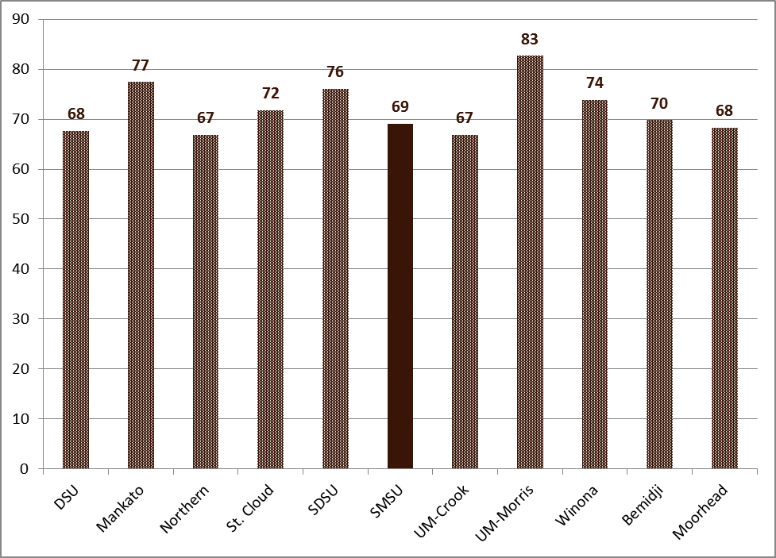
Over the past 20 years, SMSU’s completion rate has risen from approximately 30% to near 40%. The past five cohorts for which data is available all track near this 40% line. Since 1995, only once has the six-year completion rate dipped below 39% (38.8% in 2002). Twice the completion rate has topped 47% (1998 and 2001); see Figure 4.x.

Figure 4.x SMSU Completion rates since 1991

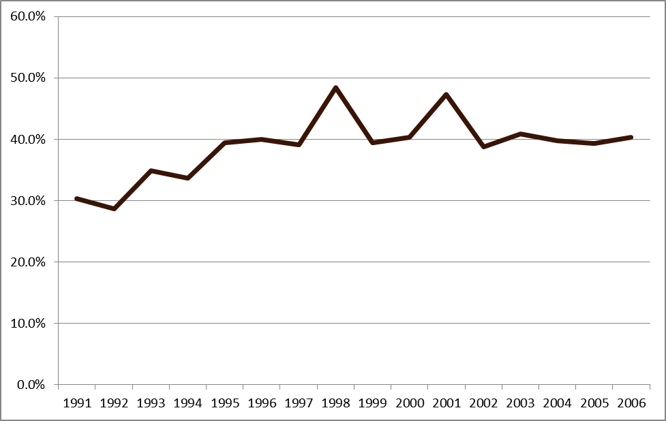

Transfer student graduation rates have consistently topped the 50% mark for recent cohort groups. Overall, the full-time student composite graduation rate for the past five cohorts of all Degree-Seeking students (Traditional/NEF and transfer) has been 43.8%. Figure 4.x shows the completion rate for these past five cohorts.

Figure 4.x Degree-Seeking Cohort Completion Rate for Cohorts Years Fall 2002 to Fall 2006

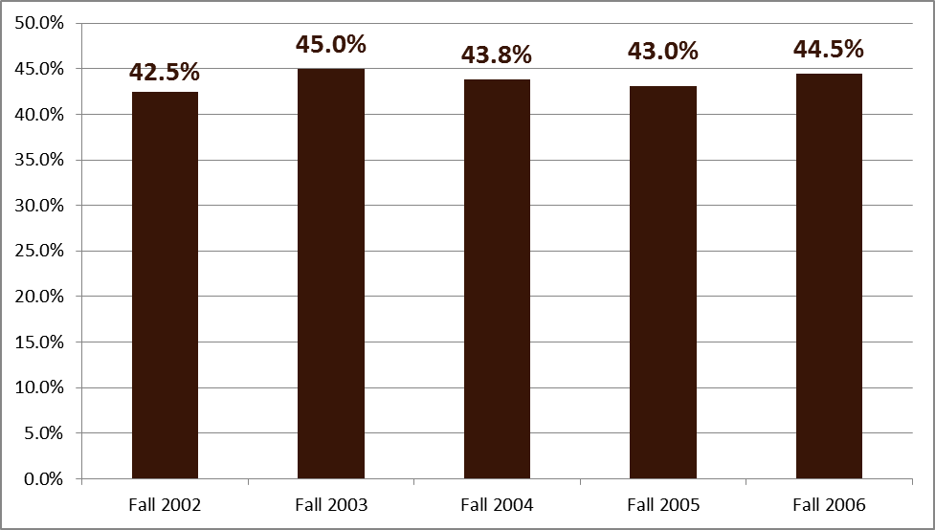
Completion, though extremely important, is also one of the most complex topics in higher education. First, the measure itself is four to six years in the making. Policies, procedures, and goals enacted now, may not be adequately analyzed for success or failure for a decade. The make-up or the size of an entering cohort can skew results years after admission decisions were made. Factors that might initially be cheered as increasing enrollment might result in declining completion. In short, merely setting a goal for completion will not likely result in improved completion rates six years down the road.
In recent years SMSU has committed more resources toward improving student success outcomes measured in retention, persistence, and completion rates. In so doing, SMSU has increased its understanding of the potential opportunities for assisting students and also some of the realities that pull down SMSU’s rates. For example, SMSU has found that embedded in that seemingly well-defined NEF cohort exist an increasing number of sub-groups. As such, there exists no certainty that SMSU’s 40% completion rate will remain steady. Further, since completion is measured at a minimum four years after the cohort’s start and more appropriately after 6 years, many additional factors may contribute to a cohort’s ultimate success.
For SMSU, the NEF group is made up of sub-groups that all have varying degrees of measured success. Here are a few sub-groups worth describing:
- Traditional 18-19 year-old recent HS graduates
- Traditional 18-20 year-old recent HS graduates with one semester or more of college credit
- International students
- Students older than 20 years of age
- Probationary students

The retention rate for each of these groups is shown in Figure 4.x Average Retention by Select Sub-groups of NEF.

Figure 4.x: Average Retention by Select Sub-Groups of NEF
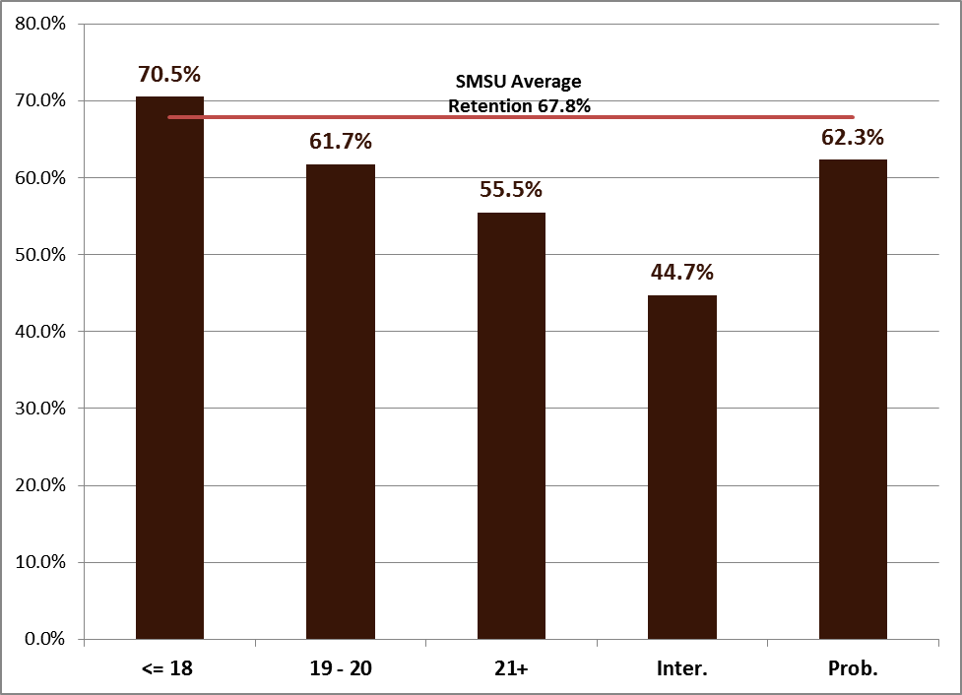
As the table shows, these various subgroups have very different historical retention rates. Thus, SMSU is developing better processes to try to identify and assist these varied student groups earlier.
Additionally, there have long been anecdotal stories of students using SMSU as a cost-saving institution from which they always planned on transferring. From a pure data perspective, there seems to be some validity to this idea. Figure 4.x that shows the percentage of each cohort that had transferred to another institution for the students’ second academic year. Admittedly, on the surface such a statistic could show that students are unsatisfied with SMSU. However, exit surveys and exit interviews provide substantiating documentation that many students are not simply dissatisfied with SMSU.

Figure 4.x NEF Cohort 2nd year Transfer Out rate
With evidence suggesting that roughly 10% of the NEF cohort always intend to transfer, that becomes a rather strong headwind for SMSU to overcome while trying to raise retention and completion rates.
In addition to transfer-related issues, the “Completion Analysis” report from summer of 2013 [link again] provides detailed analysis of retention and completion for other various subgroups, including by admission status (in good standing and provisional admits), ACT composite score, class rank, student age, first generation status, Pell eligibility, gender, race/ethnicity, and different combinations of these factors. Two of these categories demonstrate areas of concern related to completion: gender, in which female students in all cohort groups (NEF, transfer, degree-seeking) have a higher composite completion rate than their male counterparts, particularly within the NEF cohort; and race/ethnicity, in which all non-white cohort groups have markedly lower completion rates, as shown in Figure 4.x:

Figure 4.x: NEF Cohort Composite Completion by Race/Ethnicity (with Average # of students in cohort)
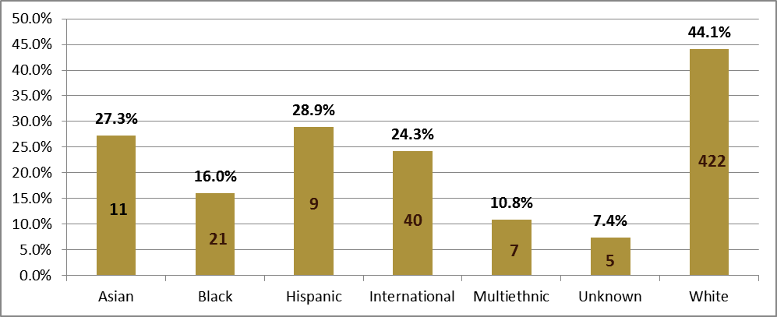

Persistence
The goal of serving students well can be seen in the long-term persistence data available from the National Student Clearinghouse. That data, represented in Figure 4.x, shows that three out of four NEF cohort students have graduated or are still enrolled in higher education 6 years after first enrolling. A 75% long-term persistence rate is a standard SMSU hopes to maintain and hopefully improve upon.

Figure 4.x NEF Long-term persistence detail
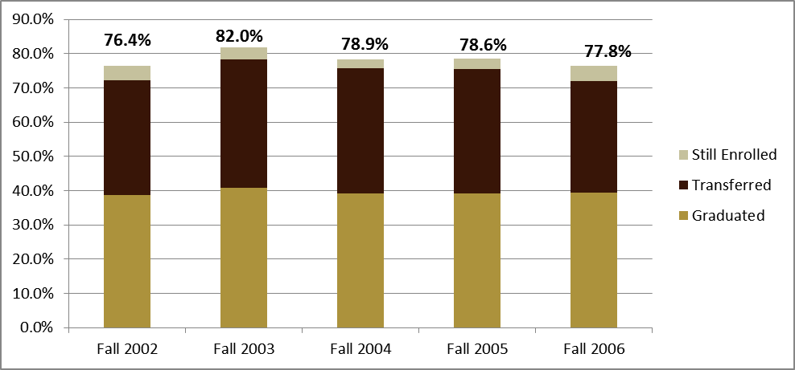
Within MnSCU, SMSU’s performance has also been quite positive. Since 2009, SMSU’s persistence as measured within MnSCU’s system goals (looking at persistence through a cohort’s second fall of enrollment) has ranked third amongst MnSCU’s seven sister universities. This measure of persistence takes into account students that have been retained, transferred, and potentially even graduated to create a total figure. For the Fall 2011 cohort, SMSU’s persistence rate was 87.7%.

Using Data to Focus on Student Needs
Based on analysis of data, SMSU is making efforts to begin earlier and earlier to identify and address concerns, issues, and potential indicators pointing toward student attrition. For example, a Retention Task Force was created during the 2012-2013 academic year. The task force was led by a Special Assistant to the President for Retention and Advising, hired by President Wood to investigate retention-related issues at the University and make suggestions for improvement. The task force completed a review of all areas of the University, culminating in a final report including elements of a retention plan. A pilot program called Building Connections was also developed by the Special Assistant to the President for Retention and Advising. This program ran for two years and focused on “middle class” freshmen students who were not admitted provisionally, yet also were not honors students. During the first year of the program, 24 students participated. During the second year, participation doubled to 48 students. The program had success with increases in freshmen to sophomore retention rates of the students who participated both years. (See also Section 4B2/4B3 “Liberal Education Program Assessment” for more information on this program.)
Beginning in Fall 2010, SMSU implemented a student relationship software (Hobson’s Retain). Efforts related to using Hobson’s Retain to develop a new early alert system led to the establishment of the Office of Student Success, initially called the Office of Retention, in 2011-2012. This office has been charged with using the early alert warning system to help identify students who are at-risk so that intervention strategies can be employed, developing a Mustang Mentor program to help new students become acclimated to campus, and creating an exit procedure to collect feedback from students who leave SMSU.
The early alert system appears to help with the goal of increasing retention. This system engages faculty within the first weeks of a semester in an attempt to identify and intervene with students that are struggling in academic, social, or other perceived ways. The Early Alert system has been fully implemented and used since Fall 2012 (AY 2013). Although the sample size is limited early report measures show the potential of early intervention. For all students that received an early alert during the fall semester of AY 2013, the fall-to-fall retention rate was between 60.5% and 63.9%. Due to resources, time, and student availability, the OSS has been able to meet with roughly 30-40% of alert recipients during each semester. However, for those students, that OSS was able to have a direct interaction with during Fall 2012 the retention rate is markedly improved (See Table 4.X below).

Table 4.X: Comparison of Early Alert Recipients Retention from Fall 2012 to Fall 2013. Total alerts and whether they met with the OSS.

 |  |  |  | Met with OSS
Term | Period | Categories | Total | No | Yes | Diff.
Fall | Week 3 | Total | 227 | 99 | 128
 |  | Returned | 145 | 55 | 90
 |  | Rate | 63.9% | 55.6% | 70.3% | 14.8%
 | Week8 | Total | 294 | 216 | 78
 |  | Returned | 178 | 123 | 55
 |  | Rate | 60.5% | 56.9% | 70.5% | 13.6%

The figures present both the potential of early intervention as well as the resource constraints SMSU has been facing. One potential solution is the reallocation of personnel resources as part of an Early Alert Team that would be trained by and work with the OSS during particular periods of the semester to assist in directly intervening with these identified at-risk students.

Another initiative of the OSS grew from the work that began under the Building Connections pilot program. Using the formula of instructor and student mentoring, the OSS partnered with faculty during the Fall 2013 (AY 2014) in three sections of First Year Seminar/LEP 100 to have student mentors involved with the course. Although preliminary and again, limited in scope, such supplemental assistance appears to hold value. When comparing Fall semester to Spring semester retention from those enrolled in all of the FYS/LEP 100 courses, there was a general similarity in overall retention across courses. However, in particular all three sections involving student mentors specifically outperformed the overall retention of male students as a whole.

Outside of the OSS, another example of improved student success has been students involved with Living & Learning Communities (LLCs). Measuring federally defined New Entering Freshmen as the cohort, those students involved with LLCs are retained at a higher rate than the SMSU average. In most years, each LLC outperforms the overall SMSU rate. However, for LLCs such as AOS that that involve students from disadvantaged backgrounds and/or other at-risk factors, the overall rate and year-to-year rates do even better when compared to students within similar categories.

Figure 4.x Retention of New Entering Freshmen participating on On-Campus Living & Learning Communities. Fall 2008 to Fall 2012 cohorts

LLC | Fall 2008 | Fall 2009 | Fall 2010 | Fall 2011 | Fall 2012 | Overall
AOS | 63.3% | 84.4% | 64.3% | 57.1% | 75.0% | 69.8%
Culinology | 75.0% | 92.3% | 69.2% | 72.2% | 58.3% | 73.5%
Fine Arts | 77.4% | 71.4% | 77.8% | 95.5% | 78.6% | 80.8%
Mustang Traditions |  | 71.8% | 79.3% | 73.7% | 86.2% | 77.6%
SMSU Overall | 68.6% | 68.1% | 70.1% | 68.1% | 67.2% | 67.7%
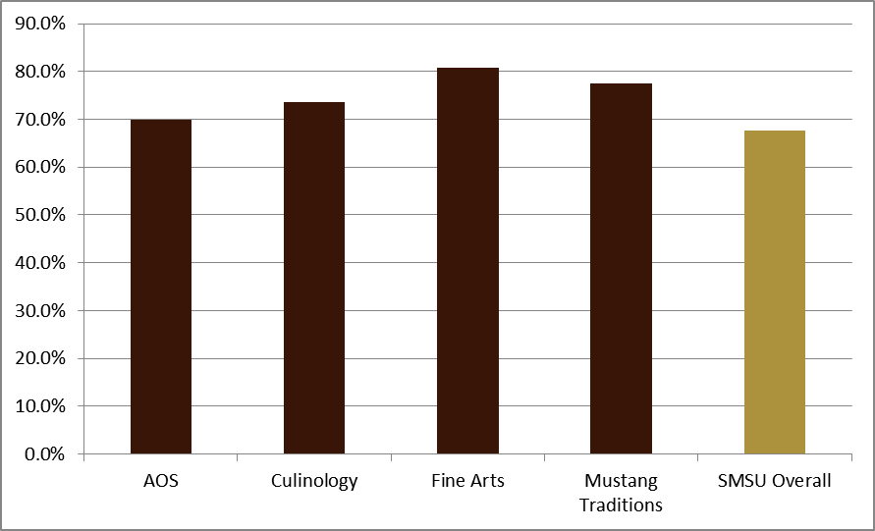

Another retention-related effort includes the Director of the Advising Center’s monitoring of students who are on academic probation. These students are invited to meet with the Director of the Advising Center to discuss SMSU academic policies, their individual academic situation, and strategies for improving their situation. There are approximately 150 students on academic probation each semester. The Director of the Advising Center meets with approximately 80-100 of these students each semester. The Director of the Advising Center also meets with approximately 15-25 students each semester, who have been suspended from SMSU, but who are returning. She discusses SMSU academic policies, their individual academic situation, and strategies for improving their situation.
4C4. The institution’s processes and methodologies for collecting and analyzing information on student retention, persistence, and completion of programs reflect good practice. (Institutions are not required to use IPEDS definitions in their determination of persistence or completion rates. Institutions are encouraged to choose measures that are suitable to their student populations, but institutions are accountable for the validity of their measures.)
As a member of Minnesota State Colleges and Universities, SMSU’s IPEDS data surveys are submitted centrally from MnSCU’s IR office. SMSU has review oversight. As such, MnSCU follows all IPEDS mandated submission definitions. Internally, SMSU uses the same IPEDS definitions for reporting official retention, persistence, and completion data (with exception of preliminary retention figures, for which SMSU and MnSCU use the same source data tables compiled by MnSCU).

However, IPEDS definitions are very narrow in scope and only apply to approximately 40% of SMSU’s total student population. Moreover, IPEDS rates do not provide broad insights into long-term student persistence, specific variables impacting retention, and various institution-level persistence concerns and goals. Thus, SMSU also compiles and analyzes data using a broader dataset that includes a wider range of bio/demographic, financial, and academic criteria. Wherever and whenever possible, these analyses follow IPEDS guidelines as closely as is possible.

Criterion 4: Strengths and Recommendations

Strengths
- Over the past four years, efforts aimed at building a culture of assessment at SMSU have been developed, enhanced, and implemented, with renewed funding and structural supports
- Faculty have numerous professional development opportunities including instruction regarding assessment of student learning at the institutional level and system level
- A full LEP assessment plan is implemented, with AHA teams supported with a duty day to establish baselines
- There is a clear cycle of program review, increasing completion rates of those reviews, and continuous spiral of improvement linked to the reviews
- College Now is accredited and has initial assessments that mirror on-campus assessment in addition to service goals
- More evidence-based decision-making is occurring throughout university
- SMSU has a very high employment rate of its graduates
- SMSU has current policies that guide transcription of credit and procedures that ensure rigor
- Student Affairs assessment has shifted to include learning outcomes in addition to programmatic outcomes
- Retention has been well studied, and analysis of retention has led to concrete, evidence-based initiatives such as the Office of Student Success, with more initiatives forthcoming

Recommendations
- Continue to develop clear lines of communication and reporting regarding assessment processes and sharing of information
- Develop better archives of assessment efforts
- Strengthen the manner in which College Now is assessed across all disciplines
- Review College Now high school instructors’ credentials and ensure that all future partnerships align with HLC’s new guidelines for dual credit
- Review retention, completion, and persistence goals so that goals are set with regard to data analysis
- Continue to use retention and completion data to develop and support University strategies for helping all students, especially those currently not well retained, to achieve their educational goals
- Continue to recognize and enhance the relationship between the co-curriculum and core curriculum via collaborations between Student Affairs and academic programs
- Review the internal survey instruments currently in use and revise to ensure the data being collected are what is most useful
- Review program internship policies and the overall SMSU internship policy to ensure the overall policy addresses needs of programs and that program policies are consistent with the overall policy

All Degree-Seeking Full-Time Traditional and Transfer students
Students receiving alerts during the Week 3 alerts were retained at 63.9%. Students receiving alerts during Week 7 alerts were 60.5%.
Overall male fall to spring retention of 87.8% in all LEP courses. In the specified sections male retention was 93.9% or a 6.1% improvement.

